PREVENTION 2030

Action plan for Country X




















V1 2026-02
TEMPLATE – DO NOT CITE

CONTENTS

3 | INTRODUCTION AND CONTEXT  The urgent need to accelerate progress
5 | OBJECTIVES  The xx by 30 HIV prevention campaign
7 | PARADIGM SHIFT  A new era of HIV prevention
9 | 2030 Prevention ACCESS Framework  A person-centred approach to access and choice
13 | PREVENTION FINANCING AND SUSTAINABILITY  Transformations to the prevention response system
15 | CONCLUSION  Call to action for country-partners

THIS TEMPLATE IS MEANT TO FACILITATE DEVELOPING OF NATIONAL PREVENTION PLANS. TEXT ELEMENTS ARE SOLELY SUGGESTIONS. THE STRUCTURE FOLLOWS A GLOBAL FRAMEWORK DEVELOPED VIA MULTI-COUNTRY CONSULTATIONS. COUNTRIES ARE ENCOURAGED TO ADAPT AND CHANGE ALL CONTENT AS RELEVANT. NOTE TO EDITORS – REMOVE ALL BLUE EXPLANATIONS IN THE END:

INTRODUCTION AND CONTEXT

The urgent need to accelerate progress

In Country X 2025 HIV prevention targets were not achieved. By the end of 2025, new HIV acquisitions had reached … , a x% change compared to 2010.

FIGURE 1. Trend in New HIV Acquisitions, 2010 to 2025, and 2030 target (see Prevention Scorecard file)

Source: UNAIDS epidemiological estimates 2025

Key groups remain underserved, with HIV prevention coverage at …

The urgent need to sustain primary prevention

2025 marked the beginning of the most severe funding crisis the global HIV response has ever seen. The implications of the funding cuts for HIV prevention in the country were …

ELABORATE HERE ANY (MODELLING) ANALYSIS TO SHOW EFFECTS OF SUSTAINING PRIMARY PREVENTION AND OTHER BACKGROUND.

BOLD VISION

By 2030, every person at risk of HIV will have access to a prevention option that suits their needs.

OBJECTIVES

The 2030 country prevention access push

In line with its international commitments, the country aims to achieve a 90% reduction in new HIV infections from 2010 to 2030, viral suppression for 90% of all people living with HIV and 90% of people in need of prevention using effective prevention options (Figure 2a). Based on a prevention needs estimation analysis, this was translated into country milestones. (Figure 2b):

FIGURE 2. Overall targets and milestones

- Coverage and outcome targets in line with global goals and commitments

DENOMINATOR | COVERAGE | OUTCOME
People in need of HIV prevention | 95% of people in need of prevention reached with HIV prevention | 90% of people in need of prevention use effective prevention options
Young people and adults  (in areas with elevated HIV)  Key populations  (sex workers, gay men and other men who sex with men, transgender people, people who inject drugs, people in prisons and other closed settings)  People living with HIV | Translated into  - 95% of people reached with person-centered prevention programmes  - Country distribution need met for condoms, PrEP, PEP, needles, syringes, OAMT)  - 90% of adolescents and young people receive comprehensive sexuality education | Translated into  - 80% condom use with non-regular partners  - Up to 80% use of ARV-based preention – PrEP including long-acting products in line with epidemiology and people’s choices  Population-specific targets:  - 90% of boys & men accessed VMMC in 15 priority countries  - 95% of people who inject drugs use safe injecting equipment, 50% of people who inject opioids on OAMT  - 95% condom use at paid sex among sex workers and clients

- Country top-line milestones for reducing HIV incidence - REPLACE ILLUSTRATIVE VALUES

1.1  MILLION | + | 350  THOUSAND |  | + | 85  MILLION |  | + | >20  PERCENT | = | 90%  of people in need use prevention options
People living with HIV accessing treatment | + | People using PrEP options |  | + | Condoms |  | + | Of domestic HIV  funding goes to  prevention | = | 90%  of people living with HIV virally suppressed
And this could be translated into district targets as well |  | 1.3 MILLION | Women & girls, boys & men in locations with high HIV |  |  | Reached with combination prevention  Highly focused behavioral, biomedical and structural elements with additional population-specific sub-targets for an optimized mix of interventions and access platforms |  |  | = | 90%  reduction in new HIV infections  from 2010 to 2030
And this could be translated into district targets as well |  | 80 THOUSAND | Key populations  (with 9 500 using harm reduction) |  |  |  |  |  | = | 90%  reduction in new HIV infections  from 2010 to 2030
Contribution of other HIV response targets, enablers and systems

- Country outcome targets – ADAPT TO COUNTRY CONTEXT

RESULT | BASELINE | 2030 TARGET
Percent of people in need of prevention use effective prevention options  Women 15-49  Men 15-49  Sex workers  Men who have sex with men  People who inject drugs  Transgender people | XX%  XX%  XX%  XX%  XX%  XX%  XX%  (estimate by adding users of condoms, PrEP, harm reduction against denominator) | 90%  90%  90%  90%  90%  90%  90%  (integrate combined HIV prevention use indicator into population-based survey or repeat baseline estimate)
Percent of people using condoms with non-regular partner  Women 15-49  Men 15-49 | XX%  XX% | 80%  80%
PrEP need met (based on differentiated targets by population between 0 and 80%) | XX% | 100%
Percent of people who inject drugs use safe injecting equipment  Percent of people who inject opioids on OAMT | XX%  XX% | 95%  50%
Percent condom use at paid sex among sex workers and clients | XX% | 95%
Percent of of boys & men accessed VMMC (only applies in 15 priority countries | XX% | 90%

Numeric targets for people and prevention options

TABLE 1. Country HIV Prevention Annual Access Targets

- Annual targets 2026-2030

 | 2024 (baseline) | 2026 | 2027 | 2028 | 2029 | 2030
Condoms*
PrEP (person years)
VMMC
Women & girls in locations with elevated HIV incidence (>0.2%)
Men and boys in locations with elevated HIV incidence (>0.2%)
Sex Workers reached
MSM reached
TG people reached
PWID reached with needles & syringes
PWID receiving OAMT
Prisoners

- 2030 targets by prevention option and sub-population in low and middle income countries

 | Women & Girls | Men & boys | Sex workers | MSM | TG | PWID | Prisoners
Condoms
PrEP (person years)

PARADIGM SHIFT (OPTIONAL SECTION)
A new era of HIV prevention

The new context, challenges and opportunities mean nothing less than a new era of HIV prevention. With strategic shifts and investments (Figure 3), it is achievable that every person at risk of HIV will have access to a prevention option that suits their needs by 2030

FIGURE 3. The Paradigm Shift for Prevention 2030 (adapt)

FROM |  | TO
2025 |  | 2030
- Intervention-centred |  | - Person-centred
- Few choices, most requiring daily adherence |  | - More short- and long-term options
- Multi-layered roadmaps  (5 pillars, 10 actions) |  | - Focused access framework
- Many aspirational long-term goals |  | - Clear top-line annual numeric targets
- Project-based activities |  | - One national program
- Mostly provider-initiated |  | - Self-care models widely available
- High donor dependence |  | - Country-led ownership and investment framework

2030 Prevention Framework
A person-centred approach to access and choice

This plan is conceptualized around the four dimensions of a person’s prevention journey. People in need of HIV prevention should be enabled to: (1) understand their prevention need, options and benefits, (2) access prevention services, (3) use prevention options effectively, and (4) experience a supportive environment. These four dimensions feature behavioural, biomedical, structural and systems-related considerations.

- People-centred design & communications (Behavioural)

All HIV prevention options depend on a person’s choice to use them. It is therefore critical to address key factors influencing decision-making including people’s HIV prevention knowledge, which is still incomplete (), understanding of personal risk, where to access services, and how to make empowered decisions.

Specific steps in this area include (elaborate based on relevant guidance () and describe main approaches – detailed activities are described in the Action Plan in the Annex in Action area 1)

- Prevention access platforms (systems)

Sustainable HIV prevention requires a well-defined country-led system to provide access through different health and non-health platforms.

(Determine the country-specific mix of access points. A government-led, multi-stakeholder process can define the access points for all relevant populations and prevention options including public, private, and community-led services. The suite of available platforms will be resource-dependent and should be evidence-informed and scalable. Countries should map out prevention access by population and by platform and consider relevance, feasibility, privacy, safety and accessibility, which all vary for different sub-populations. Collaboration across sectors remains critical to expand HIV prevention delivery platforms, including education (schools), labour (workplaces), and others.). Align this section to the Action Plan in the Annex in Action area 2.

FIGURE 4. Country HIV Prevention Delivery Platforms to Maximize Choice and Access (complete and adapt either using x marks or – ideally - numeric or percentage targets to indicate a distribution)

 | Access points
By intervention | Health facilities | Community -led and other outreach | Pharmacies | Key / higher risk locations | Virtual space | Private sector outlets | Other government sectors | Dispensers
Communications
Condoms
PrEP (oral)
PrEP (injectable)
PEP
Needles & syringes
By population
Women & Girls
Men & boys
Gay men & other MSM
Sex workers
Transgender people
People who inject drugs
Prisoners

Choose and prioritize prevention platforms based on country context and preferences of key and priority populations

- Prevention options (Biomedical)

Expanding access to a choice-based HIV prevention market refers to prevention methods as well as delivery options ().Low cost multi-purpose tools like condoms and clean needles are widely relevant even where HIV is low, while benefits of PrEP are most important in settings with substantial HIV incidence as outlined further below.

In line with these considerations, Country X will
(Elaborate approaches to avail the specific prevention options, in particular condoms, PrEP/PEP, harm reduction. Detailed actions can follow in the Action Plan in the Annex in Action area 3, but this section should clearly identify the specific gaps and approaches for the different prevention options..

- Societal enablers (Structural)

Stigma and discrimination, punitive laws, and gender norms and inequality create barriers to HIV prevention services (), reduce viral suppression (), and increase HIV incidence (,). Civic space for the leadership of affected communities is also linked to improved HIV prevention outcomes (). … Improving the experiences of people in need of HIV prevention is crucial to increase access and use. To achieve this, countries can

(Identify the key barriers in access to HIV services and influencing HIV outcomes for different populations: Addressing human rights-, gender-related and other social barriers requires collaborative, and long-term investment. These barriers need to be identified as part of overall national HIV plans and strategies. This framework focuses on the HIV prevention related dimensions. Some barriers can be addressed by other sectors such as ministries of justice and gender and some by HIV advocacy groups working with these sectors and parliamentarians.)
Barriers that other sectors or overall HIV & health coordination are better placed to address The following key barriers need to be addressed in the broader HIV, health and social development response to improve the enabling environment for HIV prevention (adapt)

Implementable actions to address structural barriers within the comparative advantage of prevention programmes (adapt): HIV prevention efforts should focus on certain structural barriers that directly affect access to, and use of, prevention options and prevention behaviors - and that prevention programmes are well placed to influence. This will include:
- .

Detailed actions can follow in the Action Plan in the Annex in Action area 4

- Multisectoral stewardship (cross-cutting)

Building core capacities for HIV prevention within systems for health - including those led by affected communities and multi-sectoral elements - ensures that prevention efforts remain at the forefront of Country X’s HIV response (). Across all dimensions, strong government commitment and stewardship will be established to energize and manage Country X’s HIV prevention response and move from project-based activities to one national HIV prevention program.

To enhance stewardship of the HIV prevention response, the following key functions will be strengthened. Detailed actions can follow in the Action Plan in the Annex in Action area 5.

PREVENTION FINANCING AND SUSTAINABILITY
Transformations in the prevention investment architecture

In the 2026-2030 period HIV prevention financing needs to transition from emergency and project-financing to sustainable financing of prevention. Country X will:

- Reorganize prevention financing around a country-led investment plan.

TABLE 2. Segmentation of programme, market and shared financing (replace illustrative assumptions with country data)

Prevention options | Target  (illustrative) | Program /market segments  (share in % of products and populations to be reached) |  |  | Funding source for free & subsidized  (share in % of cost)
Prevention options | Target  (illustrative) | Free (public) | Subsidized (social marketing) | Sold (private /out of pocket) | Government | Donors
Condoms | 85 million | 50% | 30% | 20% | 50% |  | 30%
PrEP (Daily Oral) | 120 000 | 80% | 10% | 10% | 30% |  | 60%
PrEP (Long-acting) | 230 000 | 100% | - | - | 10% |  | 90%
PEP | TBC | 60% | 20% | 20% | 50% |  | 20%
VMMC | 120 000 | 90% | - | 10% | 50% |  | 50%
Needles & syringes | 2.5 million | 80% | - | 20% | 40% |  | 20%
OAMT | 4 800 | 100% | - | - | 80% |  | 20%
People-centered programs and access platforms | Target  (illustrative) | Health Facility | Outreach /Multi-sector | Virtual | Government |  | Donors
Women & girls in locations with elevated HIV incidence (>0.2%) | 900 000 | 40% | 10% | 50% | 80% |  | 20%
Men and boys in locations with elevated HIV incidence (>0.2%) | 400 000 | 10% | 10% | 80% | 80% |  | 20%
Sex Workers reached | 45 000 | 40% | 40% | 20% | 50% |  | 50%
MSM reached | 60 000 | 20% | 10% | 70% | 50% |  | 50%
TG people reached | 4 000 | 20% | 30% | 50% | 50% |  | 50%
PWID reached | 10 000 | 40% | 40% | 20% | 50% |  | 50%
Prisoners | 8 000 | 80% | - | 20% | 90% |  | 10%

CONCLUSION & COMMITMENTS
Call to action for country-led prevention

Achieving the bold vision for 2030—where every person at risk of HIV will have access to a prevention option that suits their needs—is only possible with a transformed HIV prevention response.

TABLE 3. Operationalization of the framework

Task | Suggested due date | Lead | Comments
Revise prevention denominators (people in need) and estimate prevention needs | October 2026
Set method mix tables and annual numeric access targets | October 2026
Update monitoring tools to track overall prevention use | January 2026
Map access platforms by population and product | November 2026
Analyse total market/self-care/social enterprise viability | November 2026
Estimate domestic and external funding to meet access targets | November 2026
Finalise national Prevention 2030 Action Plan | December 2026
Update Prevention 2030 scorecard | Annually
Resource tracking (incl. domestic & KP spending) | Annually
Annual peer review of performance | Annually

Detailed action plan
(elaborate and make country-specific throughout, develop into a costed plan potentially separately in spreadsheet form, apply the 5 Ps principle in all action areas for prioritization)

Component | Outputs /deliverable | Specific activities | Responsible | Cost (Currency) | Comments
Action area 1 | People-centered design and communication for HIV prevention
Targets | - 95% of people in need of prevention reached with person-centered prevention communications  - 90% of people in need of prevention know prevention options and where to access them  - 90% of people in need of prevention are motivated to use at least one proven prevention option of their choice
Engagement  Community leadership in design | - Targeted comm’s plan using trusted, accessible channels  - Feedback loops that continuously improve comm’s and service delivery
Analytics Segmentation, behavioural economics | - User journey maps and personas that inform service and message design  - Co-created, insight-driven comm’s materials tailored to diverse user needs
Interpersonal communications Individual and small group communications | - XYZ Community leadership, XZY popular opinion leaders capacitated & empowered to promote HIV prevention, supportive norms & enabling environment  - XYZ People reached with (peer-led) outreach, small group interventions  - XYZ Schools capacitated to provide comprehensive sexuality educated and country-tailored HIV prevention campaigns
Technology comunications Virtual space, AI and media comm’s | - XYZ People reached with virtual interventions  - Online and AI powered prevention counselling available as part of a broader digital health approach enabling self-care
Action area 2 | Prevention access platforms
Targets | - 95% of people in need of prevention reached through adequate prevention access platforms  - 90% of people in need of prevention know prevention options and where to access them  - 90% of people in need of prevention are motivated to use at least one proven prevention option of their choice
Health platforms  Clinics, hospitals | - XYZ people accessing prevention through health platforms  - XYZ health facilities capacitated to provide stigma-free services and access to relevant prevention options
Market platforms  Pharmacies, shops | - Total market approach for prevention options developed and market facilitation established  - XYZ people accessing prevention options through pharmacies and shops  - XYZ pharmacies capacitated to provide stigma-free services and access to relevant prevention options
Multi-sectoral platforms  Work place and venue-based | - XYZ people accessing prevention options through work places and venues (bars, hotels, transport providers  - XYZ multi-sectoral providers (specify( capacitated to provide stigma-free services and access to relevant prevention options
Key population community platforms  Peer-led outreach, safe spaces | - XYZ sex workers, XYZ gay men and other men who have sex with men, XYZ transgender people, XYZ people who inject drugs, XYZ prisoners, accessing prevention options through peer-led outreach  - XYZ peer-led outreach providers capacitated to conduct peer-led outreach
Virtual access platforms  Online prescription & distribution | - XYZ people accessing prevention options through online orders and delivery  - Online access platform for prevention options established as part of a wider self-care platform
Action area 3 | Optimized mix of prevention options
Targets | Country distribution need met for effective prevention options (in percent)
Condoms  Male and female condoms & lubricants | - XY XYZ XYZ male and XYZ XYZ female condoms distributed  - XY XYZ XYZ units of lubricant distributed
ARV-based prevention  PrEP & PEP | - Policy, regulation and training material in place for introduction of long-acting prevention options  - XY XYZ people accessing PrEP options  - XY XYZ people accessing PEP
Harm reduction  Needles, syringes, overdose prevention | - XY XYZ XYZ needles and syringes distributed  - XY XYZ people using opioid agonist treatment
Cross-cutting  Forecasting and supply systems | - Forecasting and supply system defined and integrated with national essential medicines and logistics systems
Action area 4 | Addressing barriers to prevention
Targets | 50% reduction in key populations reporting access barriers to HIV prevention  50% reduction in young people reporting access barriers to HIV prevention
Barriers affecting key populations  Service, legal, policy and social barriers | - Law enforcement institutions adopted supportive approach to key populations’ rights and prevention access and were capacitated to implement it  - Integrated structural support such as referral to legal services, protection from violence, mental health, social support into key population programming
Barriers affecting people in settings with elevated HIV  HIV prevention access related social, and gender issues affecting women, men and adolescents | - Youth-friendly health system approach implemented to ensure non-judgmental access for adolescents  - Integrated positive messaging on social and gender norms into prevention communications (Action area 1)
Wider health and social barriers  Synergies in the comparative advantage of other programmes  (list links and refer to other national plans governing these) | - Advocacy strategy implemented to transform punitive laws for key populations into supportive laws
Action area 5 | Multi-sectoral stewardship
Targets | - 20% of domestic HIV financing allocated to prevention  - Country-led sustainable prevention data system defined and operationalized  - Accountability mechanism established and applied for political, programmatic and financial commitments
Leadership Coordination & response management, accountability | - Prevention stewardship agency fully capacitated to provide multi-sector stewardship functions  - Coordination mechanism in place to ensure integration of HIV prevention across sectors  - System for quarterly sub-national and annual national performance review in place
Prevention analytics  Data for design, strategy, prioritization, monitoring | - Routine data systems for health and community include HIV prevention indicators  - System of sub-national prevention needs estimates, targets and scorecards effectively implemented
Prevention systems & financing  Sustainable systems for delivery & financing | - Social contracting mechanism in place for sub-national prevention implementers  - Prevention integrated in health insurance schemes  - Market facilitation in place to develop markets and platforms for self-care options  - Resource mobilization from domestic and international sources

ANNEXES

ANNEX 1. Estimated HIV prevention denominators

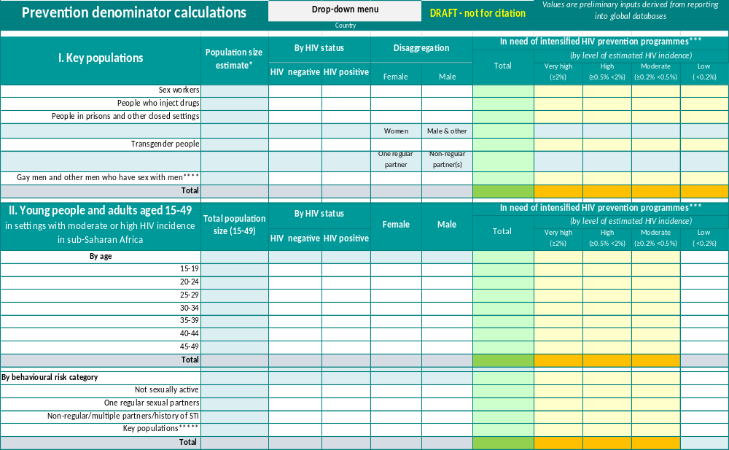

ANNEX 2. 2025 HIV Prevention Scorecard (baselines)

annex 3: Prevention optimization - enhanced prioritization in a resource constrained environment

Delete this Annex if not desired by country. It is more important to apply the principles of this Annex in the main document, than keeping this Annex.

To achieve the 2030 goals in a constrained environment, Country X will reconfigure the focus and modalities for HIV prevention. By better using existing HIV resources, it is possible to substantially reduce new HIV acquisitions by 2030.

FIGURE. Illustrative prioritization considerations based on level of HIV incidence.
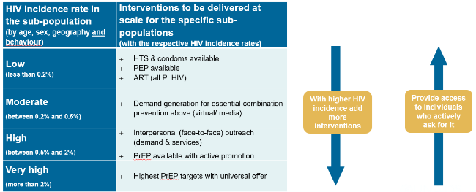

The “Five P” HIV Prevention Prioritization Matrix provides a rubric for more targeted planning and investments (Figure 11).

FIGURE 11. The “Five P” HIV Prevention Prioritization Matrix
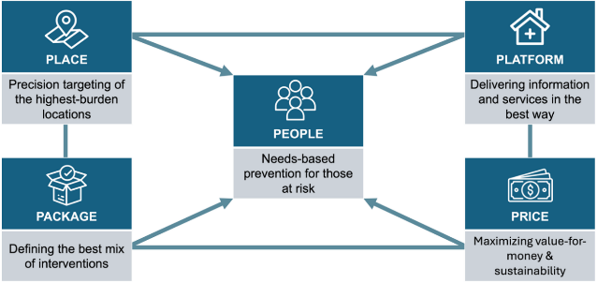
Focus on key and priority populations who need prevention most

PEOPLE: Focus on key and priority populations who need prevention most

Based on the country epidemiology HIV prevention efforts will be focused on …
People-centered precision in prevention does not mean extensive use of risk screening in service delivery to exclude people. It means extensive use of data in the design of programs, so that the right people are enabled to access relevant prevention options.

PLACE: Precision targeting of the highest HIV incidence locations

Location is a primary factor determining probability of acquiring HIV.

Based on the Sub-National HIV Incidence Estimates for Priority Populations (SHIPP), the country will prioritize ...

(Describe country geographic differentiation, possibly using a table with different regions/settings. Importantly, this approach should not exacerbate geographic inequalities and does not mean selecting only few geographies for action. Instead, precision targeting of sub-national locations will reflect intensity of action and variation in packages, where differences are substantial.)

PLATFORM: Delivering information and services in the best way

The reach and suitability of different prevention access platforms for different populations should be considered in planning.

(Elaborate any considerations on differentiation & prioritization for modalities)

PACKAGE: Defining the best mix of interventions

The prevention needs estimates based on the UNAIDS Spectrum model, represent a prioritized mix of prevention options. Three factors are key for prioritization and establishing the right mix of interventions based on cost-effectiveness:
- The HIV incidence rate in the sub-population (national estimates are available through tools like Spectrum and sub-national estimates through tools like NAOMI and SHIPP)
- Cost per person reached per year
- Assumed effectiveness of the intervention

PRICE: Maximizing value-for-money and sustainability

Ensuring the best possible price for high quality prevention medicines, commodities and services has never been more crucial. The country will transition from donor-driven costs to sustainable country government costing practice. Costs will be reduced while essential service packages, will be sustained. Savings can be made in the following areas (adapt):
- Reduce the fragmentation of delivery by streamlining types of projects and cadres into one national program
- Move to sustainable and more standardized salary and remuneration scales for human resources in line with country practice rather than donor practice
- Use high volume (international) procurement platforms for commodities
- …

REFERENCES

. https://aidsinfo.unaids.org/
. People-centred HIV prevention communication: Consolidated approaches for the demand generation and behavioural aspects of HIV prevention. Global HIV Prevention Coalition, Geneva 2026. https://hivpreventioncoalition.unaids.org/en/resources/people-centred-hiv-prevention-communication-consolidated-approaches-demand-generation-and
. Naidoo, N. P., Ayieko, J., & Fonner, V. A. (2025). Expanding access to a choice‐based multi‐method PrEP market for HIV prevention. Journal of the International AIDS Society, 28(Suppl 2), e26512. Online at https://onlinelibrary.wiley.com/doi/10.1002/jia2.26512
McKinnon, B., & Vandermorris, A. (2018). National age-of-consent laws and adolescent HIV testing in sub-Saharan Africa: a propensity-score matched study. Bulletin of the World Health Organization, 97(1), 42. Online at https://pmc.ncbi.nlm.nih.gov/articles/PMC6307515/pdf/BLT.18.212993.pdf
. Kavanagh, M. M., Agbla, S. C., Joy, M., Aneja, K., Pillinger, M., Case, A., ... & Graeden, E. (2021). Law, criminalisation and HIV in the world: have countries that criminalise achieved more or less successful pandemic response?. BMJ Global Health, 6(8), e006315. Online at https://gh.bmj.com/content/6/8/e006315
. Sia, D., Tchouaket, É. N., Hajizadeh, M., Karemere, H., Onadja, Y., & Nandi, A. (2020). The effect of gender inequality on HIV incidence in Sub-Saharan Africa. Public health, 182, 56-63. Online at https://www.sciencedirect.com/science/article/abs/pii/S003335062030024X
. Li, Y., Marshall, C. M., Rees, H. C., Nunez, A., Ezeanolue, E. E., & Ehiri, J. E. (2014). Intimate partner violence and HIV infection among women: a systematic review and meta‐analysis. African Journal of Reproduction and Gynaecological Endoscopy, 17(1). Online at https://onlinelibrary.wiley.com/doi/pdfdirect/10.7448/IAS.17.1.18845
. Lyons, C. E., Rwema, J. O. T., Makofane, K., Diouf, D., Njindam, I. M., Ba, I., ... & Baral, S. (2023). Associations between punitive policies and legal barriers to consensual same-sex sexual acts and HIV among gay men and other men who have sex with men in sub-Saharan Africa: a multicountry, respondent-driven sampling survey. The Lancet HIV, 10(3), e186-e194. Online at https://www.sciencedirect.com/science/article/am/pii/S2352301822003368
. Sustainable HIV Prevention Initiative (2025). Strengthening National Leadership for Sustainable HIV Programs: A Policy Brief for Government Leaders. Page 6. Online at https://www.blantyrepreventionstrategy.com/national-leadership-for-sustainable-hiv-programs/a-policy-brief

