PREVENTION 2030

A Global Access Framework for
Country-Led HIV Responses














V1.11.02.2026
DRAFT – DO NOT CITE

CONTENTS

3 | INTRODUCTION AND CONTEXT  The urgent need to accelerate progress
5 | OBJECTIVES  The 20 by 30 HIV prevention campaign
8 | PARADIGM SHIFT  A new era of HIV prevention
9 | 2030 Prevention ACCESS Framework  A person-centred approach to access and choice
17 | PREVENTION OPTIMIZATION  Enhanced prioritization in a resource constrained environment
21 | PREVENTION FINANCING AND SUSTAINABILITY  Transformations to the prevention investment architecture
25 | CONCLUSION  Call to action for country-led prevention

INTRODUCTION AND CONTEXT

The urgent need to accelerate progress

2025 HIV prevention targets were not achieved. By the end of 2024, new HIV acquisitions had reached their lowest levels in more than three decades, with a 40% decline compared to 2010, but missing the 2025 target of more than 80% reduction by far. Five countries—Lesotho, Malawi, Nepal, Rwanda, Zimbabwe—achieved a 75% decline by 2024 () demonstrating targets were achievable. More than 30 high-burden countries have completed or initiated at least 8 of the 10 action points in the 2025 Global HIV Prevention Roadmap (). These gains were the result of significant political will, community leadership, and global solidarity. However, globally the decline in new HIV acquisitions is far too slow to meet the 2025 (>370,000) and 2030 targets (>200,000). An estimated 1.3 million people newly acquired HIV in 2024 and even in settings with declining HIV incidence, some groups, in particular key populations, are left behind. While the epidemic is shrinking in Africa, it is stagnating and growing in other regions (Figure 1).

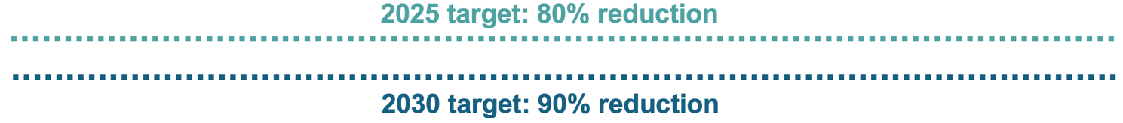
FIGURE 1. Percent Change in New HIV Acquisitions, 2010 to 2024, by Region
Asia Pacific
Caribbean
Eastern and southern Africa
Eastern
Europe and central Asia
Latin
America
Middle
East and North Africa

West and central
Africa
Western Europe and North America
Global
Source: UNAIDS epidemiological estimates 2025

Key groups remain underserved, with HIV prevention coverage at just 38% for gay men and other men who have sex with men, 39% for people who inject drugs, 44% for transgender people and 47% for sex workers (). An estimated 210,000 adolescent girls and young women (AGYW) acquired HIV in 2024—equal to 570 new acquisitions per day (). For the first time since 2012, the number of countries criminalizing same-sex sexual activity and gender expression has increased, creating barriers to prevention access and use (). Key populations and sexual and reproductive health responses are increasingly faced with organized opposition including misinformation and stigma being amplified through social media channels.

Proven effective treatment and prevention are the backbone of the response, but major scientific breakthroughs could accelerate prevention progress further. Long-acting antiretrovirals are perhaps the greatest advance in HIV in over a decade (). Artificial intelligence could automate the delivery of HIV-related information and support people in decisions related to prevention use and adherence ().

An unprecedented funding crisis

2025 marked the beginning of the most severe funding crisis the global HIV response has ever seen. The United States abruptly reduced bi-lateral HIV funding (,). The Global Fund reduced country allocations for Grant Cycle 7 (2023-2025) () and replenishment for Grant Cycle 8 remained substantially below the target and the previous cycle. Other countries such as France, the Netherlands, and the United Kingdom have also announced reductions in foreign aid of 40-70% in 2026 ().

The implications of the funding cuts are particularly drastic for HIV prevention and harm reduction. As many as 3.5 million people from key populations are no longer covered by specialized HIV prevention programs, and 2.5 million people lost access to PrEP (). Prevention systems have suffered, with 23% of 56 countries surveyed reporting six months or less of condom and PrEP stocks due to serious disruptions to the prevention commodity supply chain ().

Yet even before these cuts, HIV prevention investments were inadequate. US$ 1.7 billion–2.1 billion was available for primary prevention in low- and middle-income countries in 2024, about a third of the US$ 5.3 billion required by 2030 (). Within existing funding envelopes, prevention is underprioritized. In 2024, 10–12% of total HIV spending was directed towards HIV prevention—half of the 24% needed to reach the 2030 goals (). Further, 64 out of 82 reporting countries rely on external sources for more than 75% of their prevention funding ().

If the most catastrophic funding cuts are realized, and major donors pull all their support without mitigation, there will be an additional 6.6 million new HIV acquisitions from 2025 to 2029. However, even if treatment is sustained and only primary prevention reduced, new HIV infections would begin to rise from 2026 (Figure 2). Another analysis found that restoring funding levels for HIV treatment but not prevention would still result in nearly 1 million more new HIV infections from 2025 to 2030 (). A new path must be forged to meet the 2030 targets in a changed environment.

FIGURE 2. Impact of Reduced Funding for Prevention on New HIV Infections, 2025-2030

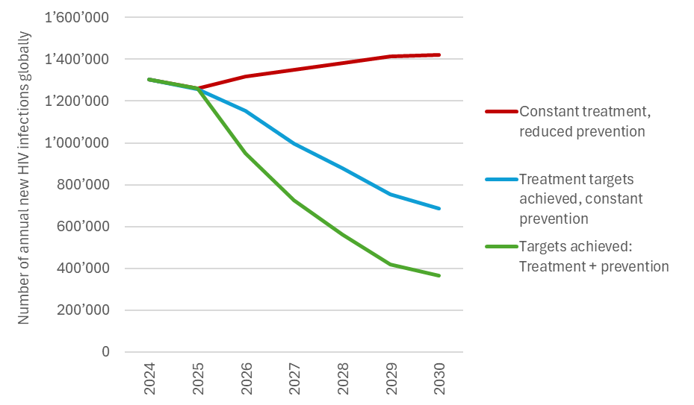
Source: Avenir Health, UNAIDS. Spectrum /GOALs model analysis

OBJECTIVES

BOLD VISION

By 2030, every person at risk of HIV will have access to a prevention option that suits their needs.

The 20 by 30 HIV prevention access campaign

The Global AIDS Strategy 2026-2031 has 15 key targets for HIV prevention (Annex 1) all in line with a bold vision for prevention access.

In addition, three top-line access goals aim to address the most critical gaps and opportunities for the next five years.

The new 40+20 Goals and an associated HIV prevention access campaign aim to harness innovations, revive the most cost-effective prevention options, and address sustainability challenges (Figure 4):

FIGURE 4. Top-line Targets for Reducing HIV Incidence
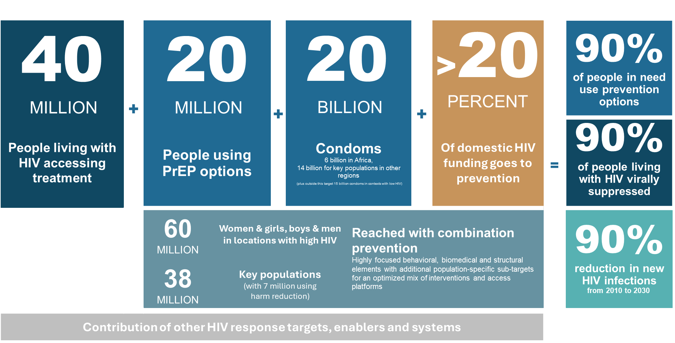

Underlying percentage targets

DENOMINATOR | COVERAGE | OUTCOME
People in need of HIV prevention | 95% of people in need of prevention reached with HIV prevention | 90% of people in need of prevention use effective prevention options
Young people and adults  (in areas with elevated HIV)  Key populations  (sex workers, gay men and other men who sex with men, transgender people, people who inject drugs, people in prisons and other closed settings)  People living with HIV | Translated into  - 95% of people reached with person-centered prevention programmes  - 95% of country distribution need met for condoms, PrEP, PEP, needles, syringes, OAMT  - 90% of adolescents and young people receive comprehensive sexuality education | Translated into  - 80% condom use with non-regular partners  - Up to 80% use of ARV-based prevention – PrEP including long-acting products in line with epidemiology and people’s choices  Population-specific targets:  - 90% of boys & men accessed VMMC in 15 priority countries  - 95% of people who inject drugs use safe injecting equipment, 50% of people who inject opioids on OAMT  - 95% condom use at paid sex among sex workers and clients

- TARGET: By 2030, ensure that 40 million people living with HIV are sustained on effective HIV treatment globally. Increasing treatment coverage will substantially contribute to reducing HIV incidence and mortality.
  - BASELINE: As of 2024, 31.6 million people living with HIV were on HIV treatment.

- TARGET: By 2030, ensure at least 20 million people are effectively using PrEP products, with a gradually increasing share of long-acting options.
  - BASELINE: As of 2024, an estimated 3.9 million people were using PrEP at least once in the year (translating into approximately 2 million person-years of PrEP use).

- TARGET: By 2030, ensure at least 60 million women & girls and men & boys in settings with high HIV are reached with combination HIV prevention programmes.
  - BASELINE: As of 2024, approximately a third of adolescent girls and young women in settings with high HIV were reached with dedicated programmes. Around half of the men & boys eligible for VMMC were reached.

- TARGET: By 2030, ensure that 35 million people from key populations (sex workers, men who have sex with men, people who inject drugs and transgender people) will be reached with combination HIV prevention.
  - BASELINE: As of 2024, in the countries reporting less than half of sex workers and a third of other key populations were reached with HIV prevention.

- TARGET: By 2030, distribute at least 20 billion condoms for various populations in sub-Saharan Africa, the region with highest heterosexual transmission of HIV taking the global condom market to an estimated 35 billion condoms (with the majority being bought by users).
  - BASELINE: Exact data are not available, but earlier analyses suggest that an estimated 3 billion condoms were targeted for HIV prevention in sub-Saharan against a need of more than 6 billion.

- TARGET: By 2030, at least 7 million people who inject drugs reached with harm reduction services including 3 million people (50%) using Opioid Agonist Maintenance Treatment and 95% accessing and using safe injecting equipment.
  - BASELINE: As of 2024, only just more than 3 out of 10 people who inject drugs were reached with harm reduction services and coverage of opioid agonist maintenance treatment was below 15%.

- TARGET: By 2030, allocate at least 20 percent of domestic HIV funding to primary prevention in line with epidemiology, while sustaining international solidarity to support most affected countries and sub-populations.
  - BASELINE: In 2023 and 2024 (48 countries), 8% of domestic HIV funding went to prevention, compared with 10% of total HIV funding.

Annual targets for people and prevention options

For clarity and accountability, national and sub-national governments are encouraged to define clear top-line annual numeric targets, based on routinized country needs estimations. The global targets are presented below in Table 1, as an example. Annex 2 shows annual prevention targets broken down by region. Annual country targets and even sub-national targets can be expressed in a similar format using annual country needs estimation processes and tools. These have been integrated into the Spectrum model that will be supported by UNAIDS and the Global HIV Prevention Coalition.

TABLE 1. Global HIV Prevention Annual Access Targets

- Annual targets 2026-2030

 | 2024 (baseline) | 2026 | 2027 | 2028 | 2029 | 2030
Condoms* | 3  billion | 3.6 | 4.2 | 4.8 | 5.4 | 6.4 billion in sub-Saharan Africa
PrEP (person years) | 2 million | 4.0 | 8.0 | 12.0 | 16.0 | 20.0 million
VMMC | 2.9 million | 1.2 | 1.2 | 1.2 | 1.2 | 1.2 million in 15 countries
Women & girls in locations with elevated HIV incidence (>0.2%) | Not available | 15.0 | 20.0 | 25.0 | 32.0 | 38.0 million
Men and boys in locations with elevated HIV incidence (>0.2%) | Not available | 6.0 | 10.0 | 15.0 | 18.0 | 22.0 million
Sex Workers reached | 47%** | 6.5 | 7.0 | 7.5 | 8.1 | 9.0 million
MSM reached | 38%** | 12.5 | 14.0 | 15.6 | 17.1 | 18.7 million
TG people reached | 44%** | 0.6 | 0.7 | 0.8 | 1.0 | 1.2 million
PWID reached with needles & syringes | 39%** | 1.7 | 2.2 | 2.7 | 3.3 | 4.2 million
PWID receiving OAMT | >15%** | 1.4 | 1.7 | 1.9 | 2.3 | 2.7 million
Prisoners | Not available | 1.0 | 1.5 | 2.0 | 2.3 | 2.6 million
* This table presents the condom targets for sub-Saharan Africa, because in other regions condom need for HIV prevention is mostly met through the private sector and tracking of total national sales volume less programmatically relevant and feasible.
** The baseline is expressed in % based on a median value for all reporting countries. However, since not all countries report these data, a numeric baseline value is not available. 2030 targets represent 90% coverage for key populations reached with combination prevention and 50% of PWID using OAMT. For prisoners targets represent 20% of the prison population. In the absence of HIV incidence data for prison populations, this was increased to 90% on a sliding scale in countries where HIV incidence in the general population exceeds 0.2% in the general population.

- 2030 targets by prevention option and sub-population in low and middle income countries

 | Women & Girls | Men & boys | Sex workers | MSM | TG | PWID
Condoms  (Sub-Saharan Africa only) | 3.8 billion (including couples, non-regular partners) |  | 2.3 billion | 0.2 billion | 0.03 billion | 0.1 billion
PrEP (person years) | 6.3 million | 2.5 million | 1.6 million | 8.0 million | 0.3 million | 1.3 million

PARADIGM SHIFT
A new era of HIV prevention

The new context, challenges and opportunities mean nothing less than a new era of HIV prevention. The Prevention 2030 Global Access Framework articulates a focused approach for achieving the 2030 global goals for HIV in a financially constrained environment. With strategic shifts and investments (Figure 3), it is achievable that every person at risk of HIV will have access to a prevention option that suits their needs by 2030

FIGURE 3. The Paradigm Shift for Prevention 2030

FROM |  | TO
2025 |  | 2030
- Intervention-centred |  | - Person-centred
- Few choices, most requiring daily adherence |  | - More short- and long-term options
- Multi-layered roadmaps  (5 pillars, 10 actions) |  | - Focused access framework
- Many aspirational long-term goals |  | - Clear top-line annual numeric targets
- Project-based activities |  | - One national program
- Mostly provider-initiated |  | - Self-care models widely available
- High donor dependence |  | - Country-led ownership and investment frameworks

2030 Prevention Framework
A person-centred approach to access and choice

“Prevention 2030” presents a focused access framework. Conceptualized around the four dimensions of a person’s prevention journey, those in need of HIV prevention must: (1) understand their prevention need, options and benefits, (2) access prevention services, (3) use prevention options effectively, and (4) experience an enabling environment (Figure 6). These four dimensions feature behavioural, biomedical, structural and systems-related considerations that may support country-led planning and investment over the next five years.

FIGURE 6. Person-Centred HIV Prevention Framework

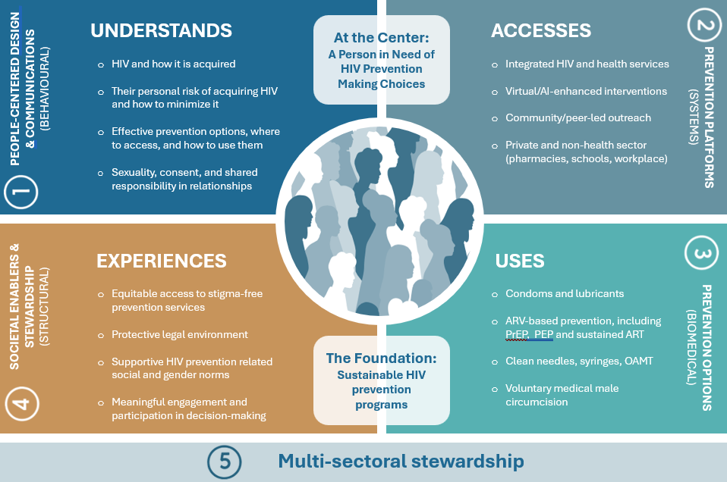

- People-centred design & communications (Behavioural)

All HIV prevention options depend on a person’s choice to use them. It is therefore critical to address key factors influencing decision-making including people’s HIV prevention knowledge, which is still incomplete (), understanding of personal risk, where to access services, and how to make empowered decisions. There is extensive research on what behavioral interventions can achieve and what not. Although early HIV incidence declines were in part linked to sexual behavior changes like reduced multiple partnerships, those changes were not sustained. Evidence supports a role of behavioral interventions in contributing to building knowledge, motivation, demand and skills required for people to make informed prevention choices and use effective prevention options, but not as stand-alone interventions expected to reduce HIV incidence on their own. In line with this, counselling and information for key populations should not aim to change underlying behaviours, but can be leveraged for engagement and should be provided in a non-judgmental manner, alongside other prevention interventions ().

New guidance outlines key principles of people-centered design and communications (). To enhance responses countries can:

- Apply people-centred design to develop one consolidated but differentiated prevention communications plan: Past prevention communication was often product- and project-specific and therefore fragmented. HIV prevention communication can now cover different prevention options rather than just specific products. Along the same lines, an overall communication approach should be designed for different audiences, rather than all groups individually, but still be differentiated to specific key and priority populations. Messages based on person-centred design are beneficial, while untargeted mass media campaigns are discouraged (). As a good example, Zimbabwe’s HIV Communications Strategy identifies the best influencers and information channels to reach different populations ().
- Develop and implement an optimized mix of prevention communications: HIV prevention communications require a mix of scaled media communications for larger target populations and, in addition, more intensive interpersonal outreach approaches for those who need it most, for example key populations or most vulnerable young people in settings with high HIV incidence. AI-enhanced HIV prevention messaging can be applied for different populations and purposes and at scale. It was shown to improve PrEP uptake (), increase condom use () and reduce behaviours that can result in HIV acquisition among vulnerable groups (). Comprehensive sexuality education (CSE) can lay an important foundation for young people to receive prevention related information and build knowledge and skills supporting sexual health. CSE should be integrated into education curricula globally and not primarily depend on HIV programming and funding.
- Assign leadership of prevention communications to one multisectoral public health entity. To optimally use limited resources an institution with multi-sectoral reach is needed to coordinate communications, in close collaboration with communities, implementers and other sectors, including harnessing private sector communications expertise.

- Prevention platforms (Systems)

Sustainable HIV prevention requires a well-defined country-led system to provide access through different health and non-health platforms. People in need of HIV prevention should be able to choose from a defined range of service delivery platforms, considering the needs of different sub-populations (Figure 7). In the past, access has in part been through fragmented, time-bound projects. This new framework applies a systems approach (). This does not mean a one size fits all approach, but a systematic approach considering feasibility, reach, preferences and barriers affecting different populations. For example, countries use different models to reach key populations at scale (). Additional guidance on sustainable, scaled HIV programmes with key populations is available () applying a differentiated model for trusted access platforms for key populations (also see Annex 5). Guidance on a differentiated model to reach adolescent girls and young women is also available.()

Taking into account their context, countries can

- Determine the country-specific mix of access points. A government-led, multi-stakeholder process can define the access points for all relevant populations and prevention options including public, private, and community-led services. The suite of available platforms will be resource-dependent and should be evidence-informed and scalable. Countries should map out prevention access by population and by platform and consider relevance, feasibility, privacy, safety and accessibility, which all vary for different sub-populations. Collaboration across sectors remains critical to expand HIV prevention delivery platforms, including education (schools), labour (workplaces), and others.
- Identify opportunities for integration to improve access: Integrating HIV prevention into primary care and sexual and reproductive health services (SRH) is a recommended sustainability approach particularly in settings with elevated HIV incidence in the general population where women and men , are routinely reached through these services (). For example, in several high-burden countries, large proportions of sexually active women access contraception , yet persistent gaps in integrating HIV into contraceptive services remain; these can be addressed using existing operational guidance. () This includes provider-initiated HIV prevention counselling, testing, , routine condom offers, and access to PrEP within contraceptive services. Conversely, SRH services —including contraception—can be integrated into HIV testing and treatment programmes. Government leadership (policy, financing, accountability) is a critical enabler for integration ().
- Develop differentiated models to improve key populations’ access: For key populations, there is need for differentiated approaches in most settings. Good examples for integration include Malaysia’s “KK Model” and Differentiated HIV Services for Key Populations approach with roles shared between government and communities, and Kenya’s integration of harm reduction into primary care facilities (,). Other successful models offer key population-led HIV prevention services that operate in public facilities with designated community engagement spaces (). However, such models only work if stigma and discrimination of key populations in services can be minimized. Where safety, confidentiality and stigma-free services cannot be guaranteed, community- and peer-led service delivery, especially through sustainable and integrated trusted access platforms, is essential to reach key populations (,).According to one multi-country analysis, an estimated 10–45% of key populations access prevention from key population-led organizations, and a further 33–51% from non-governmental organizations (NGOs) ().
- Expand use of innovative virtual and telehealth access platforms: Effective virtual platforms were developed and/or scaled during COVID-19 and should be maintained and further expanded (). Virtual platforms can enhance outreach and increase scale of peer-led outreach programmes. Telehealth options are cost-efficient, help engage harder-to-reach populations, reduce stigma, and create more accessible prevention access platforms ().
- Enable self-care approaches to HIV prevention: ‘Self-care’ for HIV prevention, when combined with strong community support, could improve access, outcomes and potentially reduce costs. This involves, for example, free self-testing and PrEP access from pharmacies and use of dispensers to access self-care products. Through chatbots, virtual check-ins, and personalized digital reminders, AI-enabled tools can support self-care prevention models (). Such self-care models can expand to transform HIV prevention away from mostly provider-initiated services, but providers themselves still have a role to enable, support and complement self-care.
- Develop a consolidated country-owned prevention data system: Strong, country-owned data and surveillance systems are needed for prevention. While there is a wide range of recommended HIV prevention data elements (), countries need to define prevention data systems that provide key coverage and outcome data for their context. Capacity for data analysis and use is also needed, including community data. Facing limited resources, countries can use model-based annual prevention needs estimates as a denominator for annual tracking that can be done more regularly than population-based surveys, which remain relevant for impact measurement but are not required annually. Lighter outcome measurement tools to complement such surveys are available.
- Ensure steady supply of prevention commodities through all relevant access platforms: Procurement and supply chain considerations are key to ensure that prevention commodities are available at the various outlets. To maximise coverage and reach, countries should minimize cost, for example by using high-volume international procurement platforms for prevention commodities regardless of funding source (). At country level existing health logistics systems and private sector retail networks can be leveraged.

FIGURE 7. Diverse HIV Prevention Delivery Platforms to Maximize Choice and Access

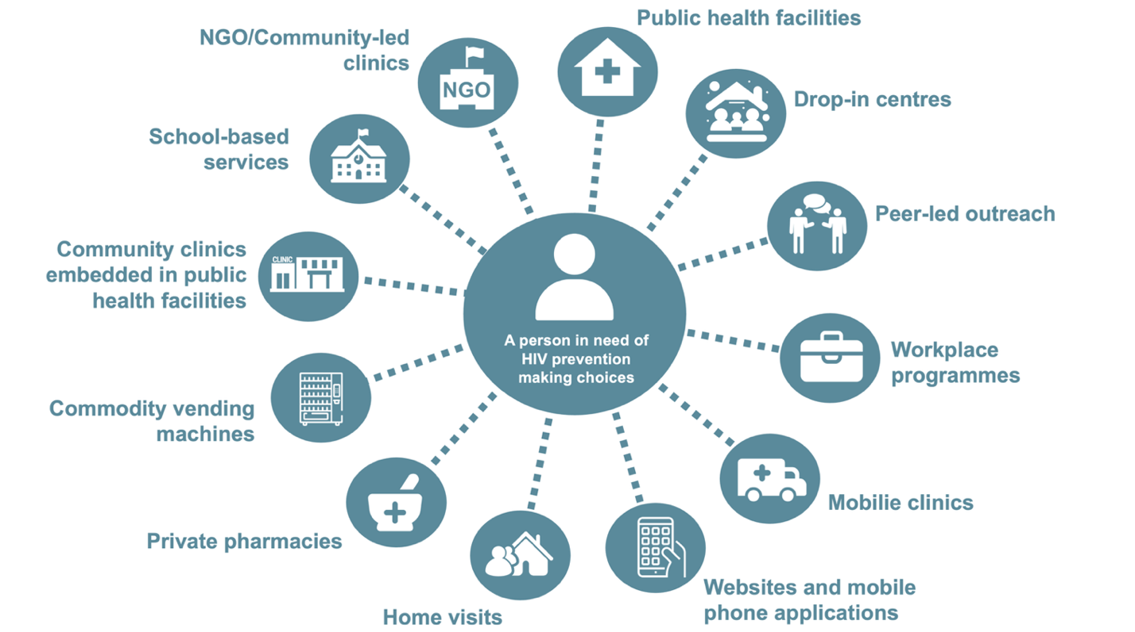

Choose and prioritize prevention platforms based on country context and preferences of key and priority populations

- Prevention options (Biomedical)

Expanding access to a choice-based HIV prevention market refers to prevention methods as well as delivery options (). With more short- and long-term options now available, a systematic approach to offering the different options will be required. The concept of choice and optimal mix of prevention methods for HIV differs partially from other fields of public health such a contraception. Different sub-populations have different preferences and needs in line with different sexual and injecting practices. In addition, low cost multi-purpose tools like condoms and clean needles are widely relevant even where HIV is low, while benefits of PrEP are most important in settings with substantial HIV incidence as outlined further below.

In line with these considerations, countries can
- Offer people structured choice of prevention products: Access to relevant options, choice and the opportunity to change products over time—not only increases prevention coverage but is also likely to be cost-effective (). Ultimately high-level of protection is the desired outcome. For example, in Australia, despite consistent condom use among MSM with casual partners falling from 42% in 2015 to 12% in 2024, PrEP use among MSM having condomless sex with casual partners increased from 1% to 49%, resulting in an overall increase in prevention use from 68% to 79% (). For other populations PrEP remains a complementary tool. For example, sex workers commonly maintain and demand continued high condom use. For people who inject drugs, harm reduction remains a top priority. Programs should focus on overall prevention coverage by people in need.
- Estimate the need for various prevention options per population: Needs estimates for specific methods are useful for planning purposes and should be done with an optimal mix in mind, always with a view to increase prevention uptake overall, not for one product. Needs estimation is a key step when planning for access and choice. See Table 1 and Annex 3 for global and regional method mix tables that can be adapted at country level for planning purposes. By 2030, more than one third of those on PrEP will be gay men and other men who have sex with men, and more than a quarter will be women and girls.
- Rapidly introduce ARV-based and new long-acting prevention technologies: Ensuring that people with the greatest need have the option to choose from the latest available prevention technologies, in addition to effective existing options, is imperative. This includes long-acting injectable PrEP formulations, the dapivirine vaginal ring (DVR) as well as oral PrEP containing tenofovir. As other options progress through clinical trials and are approved by regulatory bodies, such as once-monthly oral PrEP (MK-8527), their access must also be prioritized. Updating PrEP guidelines and accelerating regulatory approval are top priorities. Globally, a key goal is to ensure at least 20 million people are using various PrEP options by the year 2030, broken down by population (Figure 8).
- Sustain scaled and equitable access to condoms for triple protection: Condoms remain the only tool that simultaneously protects from HIV, sexually transmitted infections and unintended pregnancy. Condoms also remain the primary contraceptive choice of adolescents globally. Distribution and promotion of condoms have received reducing attention after 2010, leading to declining condom use in several countries and rising sexually transmitted infections in various settings. Countries in different regions have shown that achieving 80% condom use with non-regular partners is possible, and that downward trends in use are not universal. To prevent declining use and close gaps, countries need to actively reinvigorate condom total market approaches with complementary roles for public, social marketing and private sectors. The total global need for triple protection is estimated at 35 billion condoms. Programmatic focus on condom promotion is needed in sub-Saharan Africa to achieve an estimated target of 6 billion condoms by 2030 with country needs estimates available from 2026. The estimated need for key populations globally is 14 billion and can be met through a similar total market approach with a larger share of private sector models in countries with higher income.
- Expand access to harm reduction for people who use drugs: Evidence informed packages of harm reduction including clean needles and syringes, opioid agonist treatment and over-dose prevention (naloxone) remain highly effective prevention options that have been under-used. Scaled country-led and community-led approaches can dramatically increase access and reduce HIV transmission. Innovations such as low-dead space syringes and long-acting buprenorphine can further enhance outcomes. ()

FIGURE 8. Global Need for HIV Pre-exposure Prophylaxis (PrEP) by 2030, per Population

Source: UNAIDS HIV prevention needs estimates, Geneva 2025.

- Societal enablers (Structural)

Stigma and discrimination, punitive laws, and gender norms and inequality create barriers to HIV prevention services (), reduce viral suppression (), and increase HIV incidence (,). Civic space for the leadership of affected communities is also linked to improved HIV prevention outcomes (). Overall the legal environment for HIV prevention and key populations moderately improved globally since the 1980s, but progress stalled and in some countries was reversed, so that overall major barriers remain to be addressed.

Improving the experiences of people in need of HIV prevention is crucial to increase access and use. To achieve this, countries can

- Identify the key barriers in access to HIV services and influencing HIV outcomes for different populations: Addressing human rights-, gender-related and other social barriers requires broad, collaborative, and long-term investment. These barriers need to be identified as part of overall national HIV plans and strategies as outlined in the Global AIDS Strategy 2026-2030. This framework focuses on the prevention related dimensions.
- Define roles and comparative advantages in addressing barriers: Some barriers can be addressed by other sectors such as ministries of justice and gender and some by HIV advocacy groups working with these sectors and parliamentarians. These will vary by country but might include for example the following (also see the 2026-2031 Global AIDS Strategy)
- Advocacy for reducing the age of access to HIV prevention methods, testing, sexual reproductive health services and information.
- Decriminalisation of LGBTQI+ identities and behaviours, sex work, drug use and HIV transmission.
- Supporting the legal registration and operation of key population-led, women-led, youth-led or other community-led organizations providing HIV prevention services and ensure adequate financing.
- Expanding prevention of gender-based violence (GBV) and access to GBV services within health service delivery, with strong linkages to HIV services—including timely PEP for survivors of sexual violence.
- Promoting gender equity and women’s empowerment in development responses
- Develop implementable actions to address structural barriers within the comparative advantage of prevention programmes: HIV prevention efforts may focus on certain structural barriers that directly affect access to, and use of, prevention options and that prevention programmes are well placed to influence. This might include, for example
- Integrating messaging on supportive gender norms into HIV prevention communications (e.g., shared responsibility for protection; encouraging men to seek health services);
- Sensitization, support and monitoring of health care workers to provide respectful, equitable and non-discriminatory HIV prevention services for key populations and/or sexually active young people, including through community-led monitoring;
- Consider safety, security and confidentiality in the design of outreach, virtual and facility-based services for key populations;
- Strengthening referral pathways for legal support to uphold existing rights of key populations (e.g. in in cases of violence and discrimination);
- Analyzing and addressing inequalities in prevention access and use (e.g. by income, gender, age or other factors), including service availability, acceptability and affordability .

- Apply a human rights-based approach to HIV prevention: This includes decriminalization of key populations because punitive laws are not only ineffective, but harmful as they drive criminalized populations away from life-saving health and HIV services with negative consequences for prevention outcomes for all populations. Sustainable access to prevention requires applying minimum human rights standards for providing HIV services. This also entails removal of punitive laws and norms to create enabling legal, policy, and institutional environments that respect, protect, and fulfil the rights of people living with HIV and key populations - particularly in contexts of criminalization and shrinking civic space. These policy changes are also a low cost option for improving the operating environment for HIV prevention.

Governments, political leaders and programme managers must also recognise the challenges posed by the rise of organised mobilisation against specific populations and misinformation on social media. HIV prevention responses need to be unified around an evidence- and human rights based narrative in line with optimal public health outcomes.

- Multisectoral stewardship (cross-cutting)

Strong leadership and stewardship in HIV prevention also contributes to the prevention user experience. By building core capacities for HIV prevention within systems for health - including those led by affected communities - countries can ensure that prevention efforts remain at the forefront of their HIV responses ().

Across all dimensions, strong government commitment and stewardship will be required to energize and manage HIV prevention responses. This cohesive leadership is essential to move from project-based activities to one national HIV prevention program. Alongside governments, the leadership of affected communities will contribute to sustainable prevention systems.
Even more than for curative services, prevention requires proactive leadership. The complexity of epidemiology, different sub-populations, prevention options, multi-sectoral delivery platforms, and communication channels, requires a dedicated management mechanism with skilled human resources.

By embedding core capacities for HIV prevention within the health system, countries can ensure that prevention efforts remain at the forefront of their HIV responses (). Multi-sectoral HIV management structures remain an asset for the response, but need to be made fit for purpose. In Botswana, for example, the National AIDS Coordinating Agency became the National Health Promotion Agency in 2019, placed directly under the Office of the Presidency, with an expanded mandate to include the prevention of non-communicable diseases such as cancer and diabetes in addition to HIV (). Figure 9 describes nine key multi-sectoral stewardship functions and steps, which are elaborated in additional guidance ().

FIGURE 9. Key multi-sectoral stewardship functions for HIV prevention

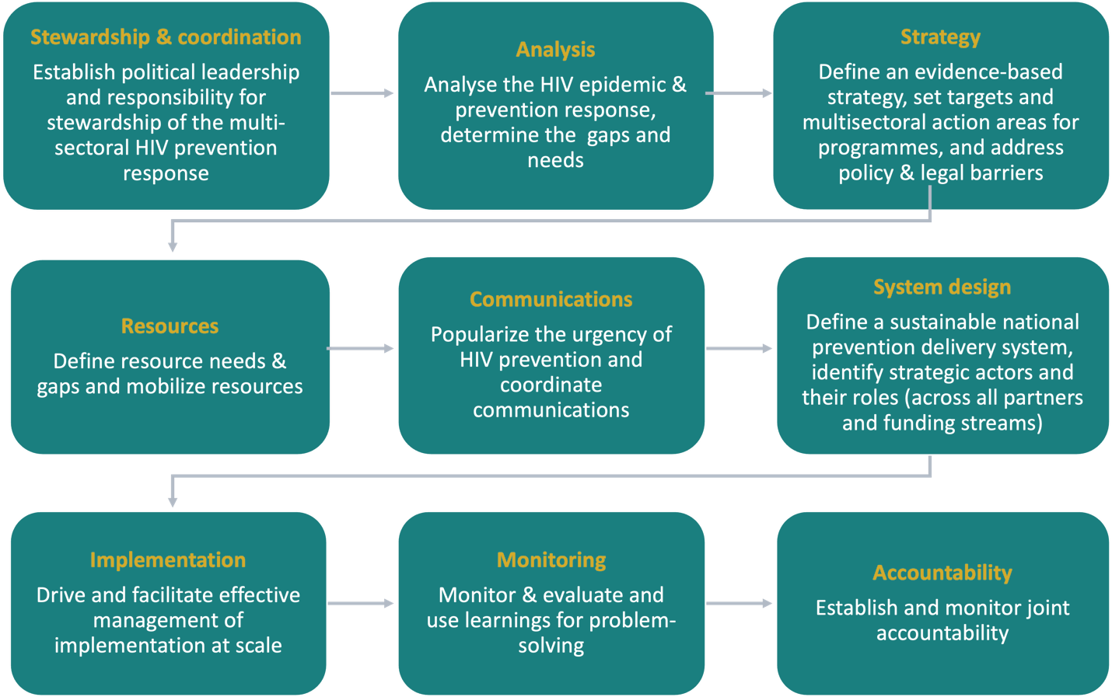

Source: HIV Leadership Forum. Global HIV Prevention Coalition. Stewarding multisectoral HIV prevention at the country level. Nairobi, Geneva 2026 (forthcoming)
PREVENTION OPTIMIZATION
Enhanced prioritization in a resource constrained environment

PREVENTION OPTIMIZATION

When people most in need receive tailored prevention packages, in the highest-burden places, through the most effective delivery platforms, at the best possible price.

To achieve the 2030 goals in a constrained environment, national HIV responses need to reconfigure the focus and modalities for HIV prevention. With fewer external resources, limited fiscal space, and competing priorities, governments face a significant challenge in sustaining HIV responses. Yet, by better using existing HIV resources, it is possible to substantially reduce new HIV acquisitions by 2030 ().

The “Five P” HIV Prevention Prioritization Matrix provides a rubric for more targeted planning and investments (Figure 11). HIV prevention is optimized when people most in need receive tailored prevention packages, in the highest-burden places, through the most effective delivery platforms, at the best possible price. At the same time, larger numbers of people at moderate risk need to be reached with scaled lower cost interventions. More detailed prevention prioritization guidance is available from UNAIDS, WHO, the Global Fund, and others (,,). See Figure 10 for an illustrative prioritization framework for resource constrained environments.

FIGURE 10. Illustrative prioritization considerations based on level of HIV incidence.
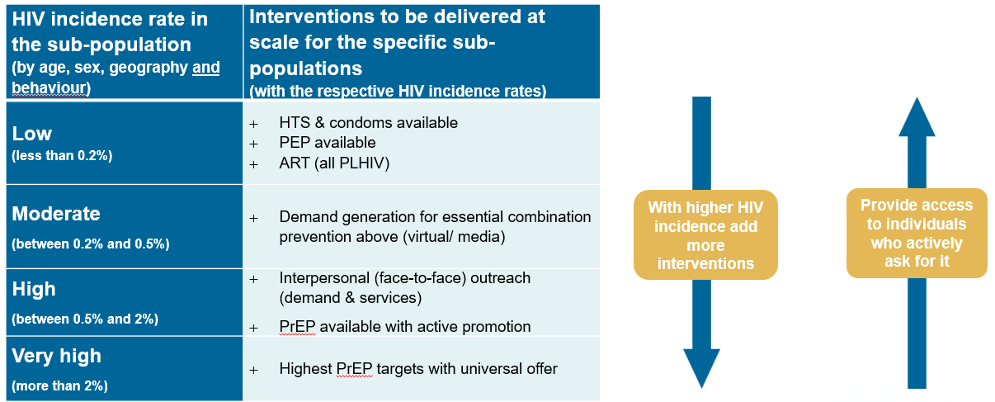

The HIV prevention needs estimates used to define 2030 targets applied the same HIV incidence thresholds, for example PrEP targets are related to the level of HIV incidence in a population, while considering population-specific factors including choices and preferences.

FIGURE 11. The “Five P” HIV Prevention Prioritization Matrix
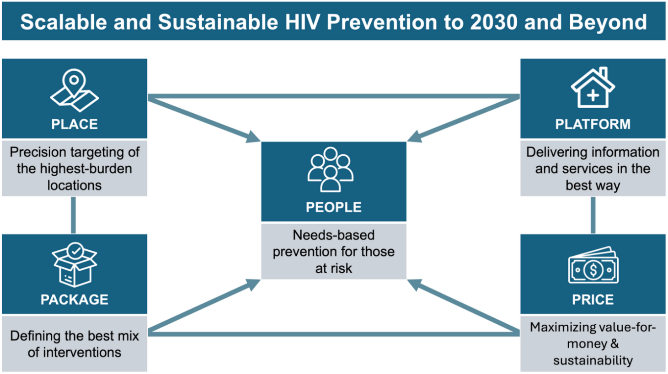
Focus on key and priority populations who need prevention most

PEOPLE: Focus on key and priority populations who need prevention most

Focusing HIV prevention efforts on key populations and their partners remains a highly effective means to reduce population‐level HIV transmission—even in many generalized epidemics (,). One model established that in three African settings, 60-80% of all new infections from 2013-2033 could be preventable through better programs with sex workers. Targeting sub-sets of priority populations can further improve cost-effectiveness. For example, in one analysis, Siaya district in Kenya, there were almost 100,000 AGYW but only 14,000 need intensified prevention (). Countries may revise their estimates of those in need of HIV prevention using the latest tools (Annex 8).
People-centered precision in prevention does not mean extensive use of risk screening in service delivery to exclude people. It means extensive use of data in the design of programs, so that the right people are enabled to access relevant prevention options.

Changing epidemic dynamics should also be considered. While MSM accounted for 9% of new adult HIV acquisitions in 2010 globally, they comprised 18% in 2022 (172 countries) (). Increasing proportions of new HIV acquisitions in sub-Saharan Africa are among women aged 25–49 years (). If resources for empirical size estimation methods are unavailable, countries may consider cheaper alternatives such as the Delphi method, wisdom of the crowds, internet search trend analysis, or regional benchmarking (Annex 4) (,).

PLACE: Precision targeting of the highest HIV incidence locations

In many settings, location is the primary factor determining lifetime probability of acquiring HIV. In Kenya, just 10 (of 47) counties accounted for 57% of new HIV acquisitions in 2021 (). In Myanmar, PWID located in borderland areas had 67% higher incidence of HIV from 2014–2021 (). In 16 sub-Saharan African countries, mine opening increases the odds of HIV acquisition in a 10km radius from the site by almost two-fold ().
Precision focus on locations does not always mean picking a few areas and only focus on those. It often means adjusting the intensity of action in all relevant locations to the level of HIV incidence in those locations.

Precision targeting of sub-national locations should also reflect variation in packages, where differences are substantial. Importantly, this approach should not exacerbate geographic inequalities. A good example is Mozambique’s HIV Prevention Roadmap 2022-2025, which defines different HIV prevention packages based on district-level incidence, including all areas (). Several countries used the Sub-National HIV Incidence Estimates for Priority Populations (SHIPP) for differentiating national HIV prevention programmes and Global Fund proposals from 2022 onwards.

PLATFORM: Delivering information and services in the best way

The reach and suitability of different prevention access platforms for different populations should be considered in planning. Key population-led HIV prevention models can be more cost-effective than public services in some contexts, including Côte d’Ivoire and Thailand (,). In Mali and Nepal, online outreach improved cost-effectiveness of HIV testing outcomes compared to all in-person services (). Differentiated service delivery for HIV prevention can yield further efficiencies. Six-month oral PrEP dispensing with HIV self-testing after three months can help increase access and minimize the costs of delivery without compromising quality ().

Depending on resource availability, countries may plan to ‘stack’ different delivery models for priority groups (Annex 5). Reducing fragmentation, while retaining necessary differentiation of delivery and standardizing human resources should be explored.

PACKAGE: Defining the best mix of interventions
Prioritization and cost-effectiveness analysis can help decide what to do and what not. However, it can also help defining what to do differently or at a lower cost for it to be viable and reach all those who need it.
The prevention needs estimates based on the UNAIDS Spectrum model, which informed 2030 prevention targets, represent a prioritized mix of prevention options. Cost-effectiveness and optimization analysis using models such as GOALS, Optima (), AEM and others can help prioritize further (). Three factors are key for prioritization and establishing the right mix of interventions based on cost-effectiveness:
- The HIV incidence rate in the sub-population (national estimates are available through tools like Spectrum and sub-national estimates through tools like NAOMI and SHIPP)
- Cost per person reached per year
- Assumed effectiveness of the intervention

Defining the ‘best mix’ of HIV prevention interventions should balance allocative efficiency modelling with individual needs and social context of communities. Ensuring user preferences are central in decision-making.
PRICE: Maximizing value-for-money and sustainability

Ensuring the best possible price for high quality prevention medicines, commodities and services has never been more crucial. Access to generics and increased competition has significantly reduced the price of PrEP and OAMT in recent years. More cost considerations are discussed in the section on prevention financing and sustainability. In settings with high dependence on external funding, the largest efficiency gains for prevention can often be achieved by transitioning from donor-driven costs to sustainable country government costing practice. Such transitions were implemented in several countries, for example India transitioned its scaled national key population programme with a large scale community system to domestic financing. Costs were reduced while essential service packages, community implementation and social contracting were sustained. For prevention programs, savings can often be made in three main areas:
- Reduce the fragmentation of delivery by streamlining types of projects and cadres into one national program
- Move to sustainable and more standardized salary and remuneration scales for human resources in line with country practice rather than donor practice
- Use high volume (international) procurement platforms for commodities

Distributional cost-effectiveness analysis is useful to evaluate how HIV outcomes and costs of prevention are distributed across different population subgroups. This may require accepting higher per-capita costs to reach criminalized and stigmatised populations with higher HIV incidence, because of the disproportionate benefits of reaching these populations for the populations themselves and the response overall.

PREVENTION FINANCING AND SUSTAINABILITY
Transformations in the prevention investment architecture

In the 2026-2030 period HIV prevention financing needs to transition from emergency and project-financing to sustainable financing of prevention in line with country systems.

By 2030, the global HIV prevention targets will require $5.2 billion annually in low- and middle-income countries, equivalent to 24% of total HIV resource needs (US$ 21.9 billion). These new resource needs estimates are lower than before due to major cost efficiencies () and enhanced prioritization. This includes a reduction in the average price of oral PrEP from about US$ 109–134 per person per year in 2019 to less than US$ 40 in 2025 (,), and significant reductions in OAMT unit costs.

FIGURE 12. Adjusted Resource Needs Estimates for HIV Prevention, 2025 vs 2030 ()

Total Need:
US$ 21.9 billion
Total Need: US$ 29.3 billion

The funding need for primary prevention varies by region, from 12% of total HIV resources in West and Central Africa to 38% in Eastern Europe and Central Asia (Figure 11).

With constrained resources, it is essential to translate prevention targets into implementable country-owned investment plans. These need to be based on sustainable country-owned costs, while maintaining shared global responsibility based on country income level.

To contextualize the ambitious global targets and investment needs, it is important to understand that more than half of total HIV primary prevention funding is needed in just eight countries—South Africa (12%), India (10%), China (6%), Brazil (6%), Pakistan (5%), Russia (5%), Indonesia (4%), and the Philippines (4%) (Annex 6).

In line with their economic and epidemic context, country governments can:

- Fundamentally reorganize prevention financing around country-led investment plans: Country-owned prevention investment plans should become the central planning instrument in all countries. In middle-income countries, the role of international partners will remain in provision of granular epidemiological and programming tools that are critical in estimating need and setting country targets as a basis for primarily domestically funded prevention responses. In low-income and lower-middle income countries with high HIV burdens, international partners will need to continue support, based on radically redefined country-owned plans and cost structures including the efficiencies outlined in the previous section.

- Apply a total market approach to HIV prevention: While not traditionally considered domestic funding, a total market approach can help address limited scale and sustainability of HIV prevention. HIV prevention is an essential health service that should be included in UHC benefit packages and remain free at the point of use for people at highest risk and those facing structural barriers. The total market approach can complement this and expand choice of access platforms and products. It recognizes that populations with higher income can buy prevention products out of pocket, while government subsidy can focus on lower income groups who cannot afford private sector prices. Social marketing and social enterprise models provide access to affordable products outside health facilities. In some contexts, commercial models can create sustainable income for community-led service providers. One MSM-led organization in Vietnam generates 60% of its income from its private clinic and pharmacy. Table 2 shows a systematic approach to shared financing for prevention. Rather than financing their own donor-led projects, the systematic approach invites donors to fund a share of a country-led programme.

TABLE 2. Example of segmentation in a total market approach and systematic approach to shared financing (illustrative assumptions for a lower income country context – for country adaptation)

Prevention options | Target  (illustrative) | Program /market segments  (share in % of products and populations to be reached) |  |  | Funding source for free & subsidized  (share in % of cost)
Prevention options | Target  (illustrative) | Free (public) | Subsidized (social marketing) | Sold (private /out of pocket) | Government | Donors
Condoms | 85 million | 50% | 30% | 20% | 50% |  | 30%
PrEP (Daily Oral) | 120 000 | 80% | 10% | 10% | 30% |  | 60%
PrEP (Long-acting) | 230 000 | 100% | - | - | 10% |  | 90%
PEP | TBC | 60% | 20% | 20% | 50% |  | 20%
VMMC | 120 000 | 90% | - | 10% | 50% |  | 50%
Needles & syringes | 2.5 million | 80% | - | 20% | 40% |  | 20%
OAMT | 4 800 | 100% | - | - | 80% |  | 20%
People-centered programs and access platforms | Target  (illustrative) | Facility | Outreach | Virtual | Government |  | Donors
Women & girls in locations with elevated HIV incidence (>0.2%) | 900 000 | 40% | 10% | 50% | 80% |  | 20%
Men and boys in locations with elevated HIV incidence (>0.2%) | 400 000 | 10% | 10% | 80% | 80% |  | 20%
Sex Workers reached | 45 000 | 40% | 40% | 20% | 50% |  | 50%
MSM reached | 60 000 | 20% | 10% | 70% | 50% |  | 50%
TG people reached | 4 000 | 20% | 30% | 50% | 50% |  | 50%
PWID reached | 10 000 | 40% | 40% | 20% | 50% |  | 50%
Prisoners | 8 000 | 80% | - | 20% | 90% |  | 10%

- Increase domestic funding for primary prevention and allocate at least 20% of domestic HIV spending to prevention: Domestic financing will determine the success of the global response () from 2026 to 2030 and beyond. Currently, nearly 80% of HIV primary prevention programs are financed externally, compared to 55% of care and treatment (). Such reliance puts primary prevention at risk. PEPFAR’s policy changes in 2025 left 719,000 PrEP users in Africa without access, potentially adding up to 16,000 new HIV acquisitions in a year (). Primary prevention requires greater prioritization overall, but especially in domestic spending (Table 3; Annex 7). Globally, on average 24% of HIV resources are required for prevention. As a benchmark and considering country context, UNAIDS calls for at least 20% of domestic HIV spending to go to primary prevention by 2030. Table 3 and Annex 7 illustrate baseline values at regional level.

TABLE 3. Proportion of HIV Resources Spent on Prevention (57 countries, 2023-2024) ()

Region | % of Total HIV Resources Spent on Prevention | % of Domestic HIV Resources Spent on Prevention
Asia-Pacific | 8% | 7%
Eastern and Southern Africa | 10% | 5%
Eastern Europe and Central Asia | 20% | 13%
Latin America and the Caribbean | 16% | 15%
Middle East and North Africa | 0.2% | 0%
Western and Central Africa | 9% | 3%
Global | 11% | 8%

- Explore innovative domestic financing modalities for HIV responses including prevention: National governments are employing innovative approaches. Kenya developed guidelines for private construction projects to support HIV prevention (). The Malaysia AIDS Foundation raised $2.25 million in 2023 through galas, private giving, and other partnerships, including $1.65 million from the government for HIV prevention among key populations (). A 2025 Cabinet Paper in Malawi called for 5% of each sector’s budget to go towards HIV prevention (). There are several viable strategies to increase domestic funding for HIV prevention:

- Including HIV prevention in the benefits package for social health insurance is a key policy issue (). Brazil and Thailand have included PrEP in their social health insurance packages since 2017 and 2021, respectively (,). It is also important to ensure cover for those in need of HIV prevention. In 2023, Cambodia expanded the Health Equity Fund eligibility criteria to include female sex workers ().

- Social contracting of community-led organizations is essential to facilitate access to prevention at community level and thereby increase uptake of HIV prevention methods (). Progress has been slow to scale up such financing mechanisms, but there are promising practices. Jamaica has socially contracted HIV prevention for MSM and transgender people since 2021 (). In 2023, Viet Nam began social contracting of harm reduction services (). Meaningful involvement of communities is critical when developing these mechanisms () and additional experiences have been documented across regions from Bolivia, Morocco, Sudan, Pakistan and Zimbabwe ().

- Special levies and taxes have been used to fund HIV prevention in several countries, including the Philippines, South Africa, Uganda, and Zimbabwe. In Uganda, 2% of tax revenue from alcohol, soft drinks, and bottled water is earmarked for HIV prevention and treatment under the HIV/AIDS Trust Fund Act of 2014 (). In the Philippines, sin tax contributions to HIV prevention and treatment have more than doubled available resources for these programs at the Department of Health ().

- To increase the likelihood of governments absorbing externally-funded HIV prevention programmes, strengthening public financial management (PFM) systems is key. On-budgeting HIV prevention funding from external sources—such that it runs through the PFM system regardless of who implements it—is associated with more successful donor transitions ().

- Provide adequate funding to ensure key populations can access prevention. In 2024, only 2.6% of total HIV funding was spent on programmes for key populations, despite accounting for an estimated 80% of new HIV infections outside sub-Saharan Africa and about 25% in sub-Saharan Africa (). By 2030, spending on HIV prevention services for key populations is estimated to require 13% of total funding (). Domestic funding for key populations is especially critical to realize, while sustaining international financing until in-country provisions for adequate budget allocations, social contracting modalities, quality and safety standards are in place.

- Ensure new prevention technologies are available, accessible, affordable and acceptable: They should be provided alongside existing effective options, including oral PrEP, to ensure meaningful choice. In addition to affordability, timely regulatory approval, inclusion in national guidelines and UHC benefit packages, and access to quality-assured generic products through voluntary licenses or other legal and policy measures will be critical for scale-up. With enough demand and scaled generic production, LEN could be manufactured at just $25 per dose (). Some countries have already generated cost-effectiveness thresholds for LEN, including Kenya ($16.60), South Africa ($106.30), and Zimbabwe ($21.10) (-). Access to LEN at a purchasing price of USD 40 for two injections was announced for 120 countries. A gap in affordability remains for many middle income countries, where a substantial proportion of the need is. As cost-effectiveness thresholds indicate, long-acting PrEP can cost slightly more than oral PrEP to remain cost-effective but not substantially more. Countries can determine the thresholds at which products will improve overall impact of the prevention response and use them in pricing advocacy and negotiations.

Economic analysis—including resource tracking, costing norms, and cost-effectiveness—is essential to monitor progress on these transformations. National AIDS Spending Assessments and other resource tracking methods remain a critical tool for understanding granular expenditure on HIV prevention, including domestic spending and spending on key populations ().

CONCLUSION & COMMITMENTS
Call to action for country-led prevention

Achieving the bold vision for 2030—where every person at risk of HIV will have access to a prevention option that suits their needs—is only possible with a transformed HIV prevention response. The Prevention 2030 Global Access Framework provides countries with a new and focused approach to achieve our goals in a constrained environment.

To operationalize Prevention 2030, countries are encouraged to develop a very brief action plan, outlining prevention transformations at country-level to increase access. The action plan may be an addendum to existing HIV Prevention Roadmaps, Strategies, or National Plans. The timeline for country-led HIV prevention planning is suggested in Figure 13. The short check-list below may guide Prevention 2030 planning at country level.

FIGURE 13. Major Milestones in 2030 HIV Planning and Commitments
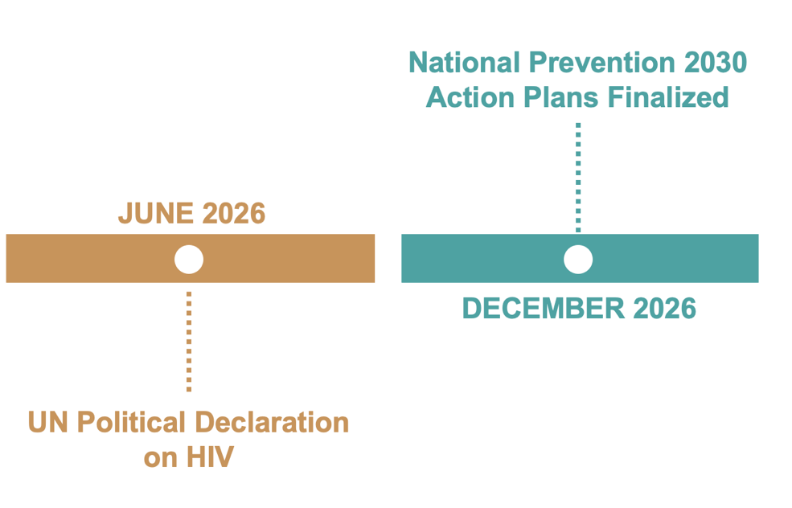
TABLE 3. Prevention 2030 Planner – Country Check-list
 |  | Due Date
 | Needs Estimates: Revise prevention denominators for those in need of targeted services | April 2026
 | Method Mix Tables: Set annual numeric access targets per population and intervention | April 2026
 | M&E Tools: Update tools to include tracking of overall HIV prevention use (i.e., any method at last exposure) | June 2026
 | Access Platforms: Map prevention use by population and product across delivery models | June 2026
 | Total Market Approach: Analyse viability of increased self-care and social enterprise | August 2026
 | Resource Needs: Estimate domestic and external funding required to meet access targets | October 2026
 | Planning: Develop National “Prevention 2030” Action Plan | December 2026
 | Monitoring: Update Prevention 2030 country scorecards | Annually
 | Resource Tracking: Assess prevention spending; focus on domestic and KP expenditure | Annually
 | Management: Conduct annual peer review of performance with sub-national and multi-sectoral entities | Annually

Call to action

Country governments will
- Set national & sub-national program, finance and impact targets based on granular needs estimates and in accordance with the 2026 UN Political Declaration, the Global AIDS Strategy 2026-31 and this access framework.
- Develop truly country-led and well-prioritized, sustainable HIV prevention plans that evolve prevention responses from fragmented projects to integrated, nationally owned programmes.
- Designate a national multisectoral leadership entity for HIV prevention and build its capacity to lead the prevention response.
- Lead and coordinate integrated health sector and multi-sectoral HIV prevention including actions in government sectors, private sector and communities.
- Ensure adequate domestic prevention financing including integration into social health insurance schemes and multi-sectoral budgets.
- Develop a country systems approach to prevention access platforms with differentiated platforms for different populations (but not separate project approaches).
- Develop and implement a support mechanism for community systems including social contracting of civil society and community-led organizations reaching key and priority populations.
- Lead a prevention push campaign and coordinate people-centered HIV prevention communications including in the virtual spaces and promoting prevention-related knowledge, norms and skills;
- Facilitate rapid regulatory process for introducing long-acting prevention products, availability and access getting the most out of limited resources and catering to people’s different preferences and shifting needs.
- Sustain investments in condoms, needles, self-tests and other self-care products applying a ‘total market approach’ with complementary roles of public, social marketing and private sectors.
- Accelerate the necessary reforms to the legal and policy environment to ensure people most affected can access HIV prevention, and adopt law enforcement practices that facilitate, rather than obstruct access to prevention.

Funding partners will
- In their own interest, sustain investment in HIV prevention in low- and middle-income countries recognizing that a pandemic cannot be ended, unless transmission is reduced in all countries.
- Support a phased transition to sustainability that will sustain access and use of prevention options and thereby achieve impact - instead of abrupt defunding.
- Engage additional funders including high and upper middle income countries and foundations in funding prevention with a systematic focus on lower income countries with high HIV and most vulnerable populations
- Align all their contributions to sustainable national prevention plans rather than donor-specific projects, support existing country health and community systems and adhere to sustainable country cost guidelines.
- Continue supporting access to basic prevention options such as condoms, clean needles and oral PrEP;
- Ensuring affordability and rapid access to innovative long-acting prevention aiming to reduce the time lag of introduction of new products in high-income and low-income countries to below 12 months.
- Reinvest savings from declining HIV commodity prices into prevention programs, and provide support to countries, including through the Global Fund and technical partners.

Community-led and other civil society organizations will
- Identify gaps and advocate for equitable access to all context-relevant HIV prevention options for all key and priority populations (including but not limited to women, men and young people in locations with high HIV, sex workers, gay men and other men who have sex with men, people who inject drugs, transgender people and prisoners).
- Lead in the development of trusted access programmes for key populations, young people, women and men including people living with HIV and work to remove barriers to access.
- Strengthen community systems, including community-led monitoring and surveillance, to improve the quality of prevention services and of data, progress tracking and reporting.
- Hold governments and other actors accountable for progress towards prevention targets through constructive advocacy, and further develop structures for feedback, communication and problem solving between community and government systems.
- Advocate for legal and policy reforms, including the removal of punitive laws, the lowering of obstructive age of access requirements.
- Develop and implement interventions to reduce HIV-related stigma and discrimination across health, community, justice, workplace, education and humanitarian settings.

Technical partners will
- Provide global leadership and stimulate political momentum for HIV prevention in line with the mandate from the 2026 UN Political Declaration
- Support granular data collection and analysis to develop prevention needs estimates, an optimal mix of prevention options and directions for most effectively using international HIV prevention financing.
- Engage countries and draw on latest evidence and country experiences to develop country capacity in HIV prevention.
- Provide guidance, tools and technical support to develop programmes; build demand; and use new delivery strategies to achieve sustained access to prevention options.
- Work with governments, industry and communities to ensure affordability, licensing and rapid regulatory approval in countries, as well as the inclusion of new prevention options as part of Universal Health Coverage.

Private sector will
- Avail private sector access platforms for HIV prevention including through pharmacies, retail networks, supply chain systems, marketing, collaboration with social enterprises and online market places.
- Advance HIV prevention in virtual spaces through generative artificial intelligence platforms and integration of prevention in dating apps and other social media platforms.
- Develop and introduce new innovative prevention products and working with low and middle-income country governments and international technical and funding partners to ensure equitable access and affordability globally.

ANNEXES

ANNEX 1: Detailed 2030 HIV Prevention Targets

 | Target | Data Source | Status
1 | 90% of people in need of prevention use appropriate, prioritized, person-centred and effective prevention options (pre-exposure prophylaxis (PrEP), post-exposure prophylaxis (PEP), condoms, needle/syringe programmes (NSPs), opioid agonist therapy (OAT) (topline). | Population-based surveys | 2025 target
2 | 80% of people use a condom at last sex with a non-regular partner. | GAM 1.14.  Population-based surveys. | New
3 | 50% of people at high risk of acquiring HIV (including key populations) use effective, ARV- based, prevention options: oral PrEP, long- acting PrEP, PEP (target levels in line with epidemiology and people's choices). | Programme records. | New
4 | 95% of sex workers and their clients used a condom at last paid sex. | IBBS, population-based surveys. | New
5 | 95% of people who inject drugs used safe injecting equipment during their last injection. | GAM 1.8. IBBS. | New
6 | 50% use of opioid agonist maintenance treatment among people who inject opioids. | GAM 1.10.  Programme data, IBBS. | 2025 target
7 | 95% of adolescent girls and young women, adult women, pregnant and breastfeeding women, and adolescent boys and men in settings with elevated HIV, effectively reached with people-centred HIV prevention programmes (HIV prevention related contact with health services, (including SRH quality services), community outreach, virtual interventions, schools or other providers). | Population-based surveys or programme data. | New
8 | 90% of schools provide life skills-based HIV and sexuality education. | Annual School Census questionnaire or the UNESCO Institute for Statistics (UIS) Annual Survey of Formal Education questionnaire. | 2025 target
9 | 95% of key populations effectively reached with people-centred HIV prevention programmes. | GAM 1.6, 1.7.  Programme data, IBBS. | 2025 target
10 | 95% of the estimated need for condoms is available and distributed. | Programme data versus needs estimates. | New
11 | 95% of the estimated need for PrEP is available and distributed. | Programme data versus needs estimates. | New
12 | 95% of the estimated need for PEP is available and distributed. | Programme data versus needs estimates. | New
13 | 95% of the estimated need for sterile syringes is available and distributed. | Programme data versus needs estimates. | New
14 | 80% of people-centred HIV prevention programmes for key populations to be delivered by community-led organizations. | Work is ongoing on measurement sources and methods. Policy data on the operating environment for community-led service delivery are being used as proxy measures. | 2025 target
15 | 90% of all people living with HIV are virally suppressed by 2030, increasing to 95% by 2040. | GAM 2.3.  Programme data plus epidemiological estimates. | New

ANNEX 2. Targets for Pre-Exposure Prophylaxis (PrEP)

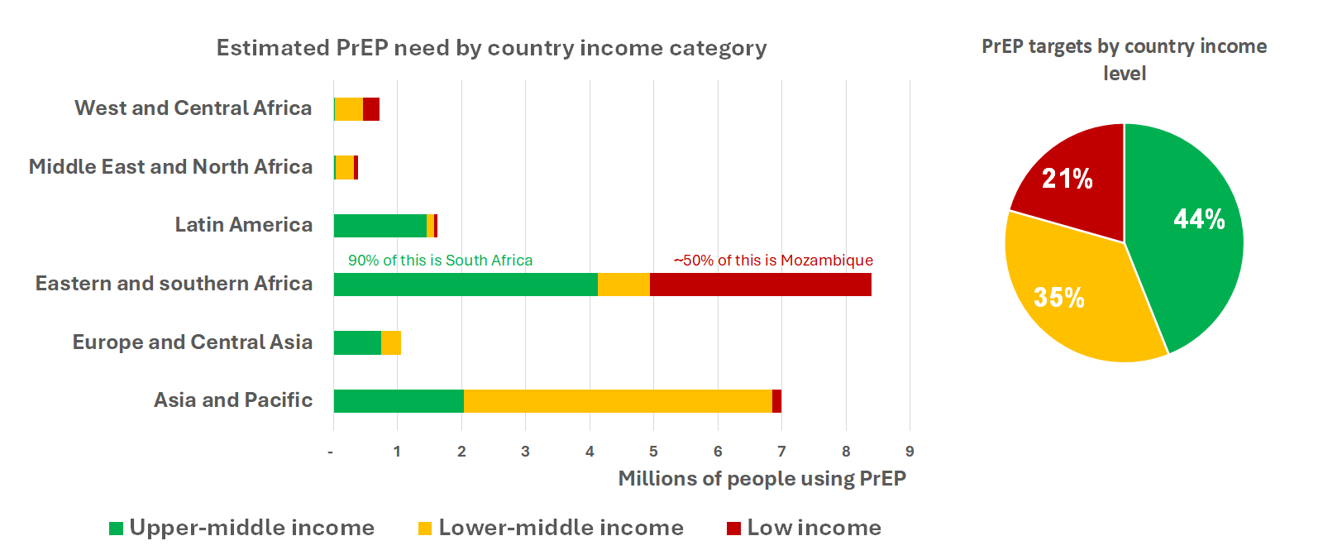
- PrEP targets by region and income level (2030)

- Assumptions underlying PrEP targets

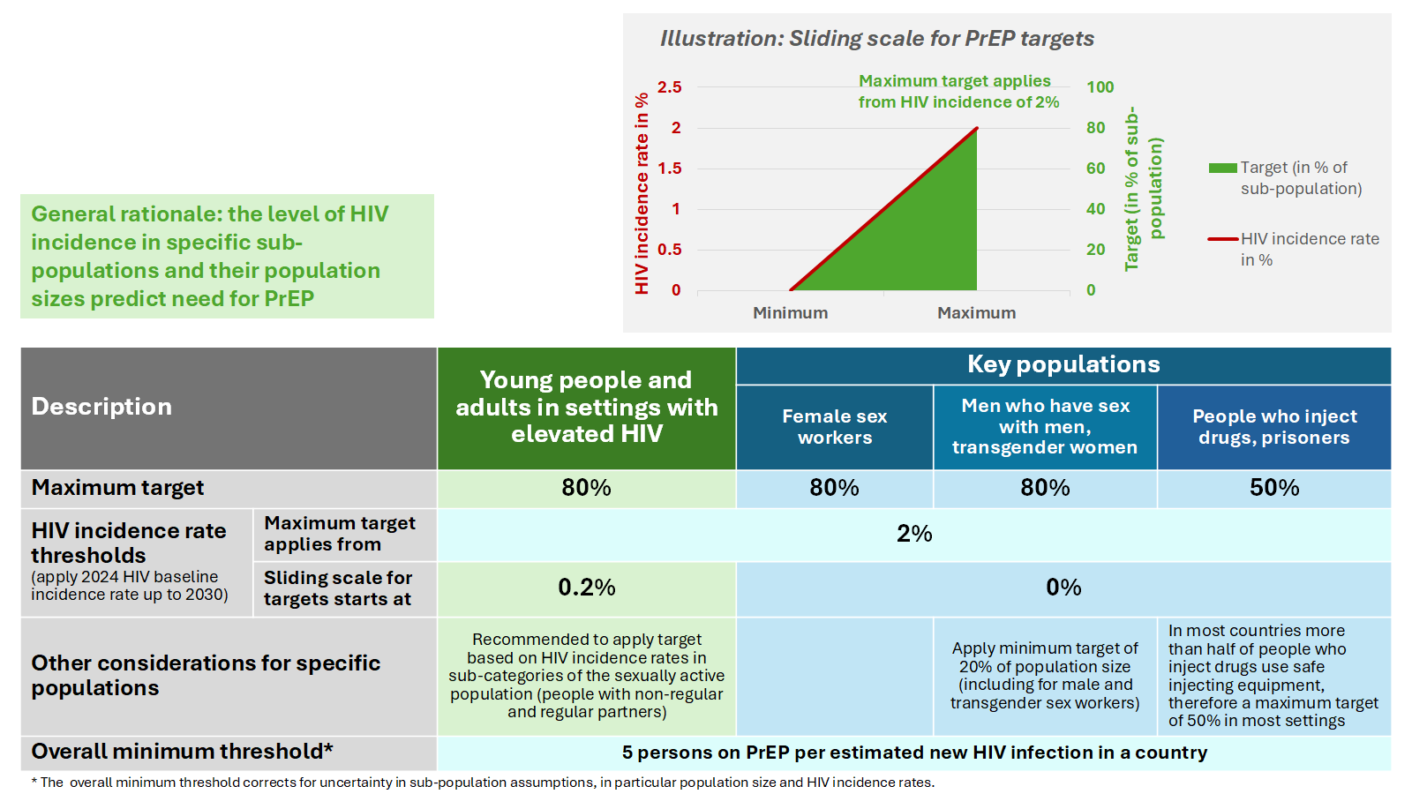

ANNEX 3. Full condom targets by region and country income group

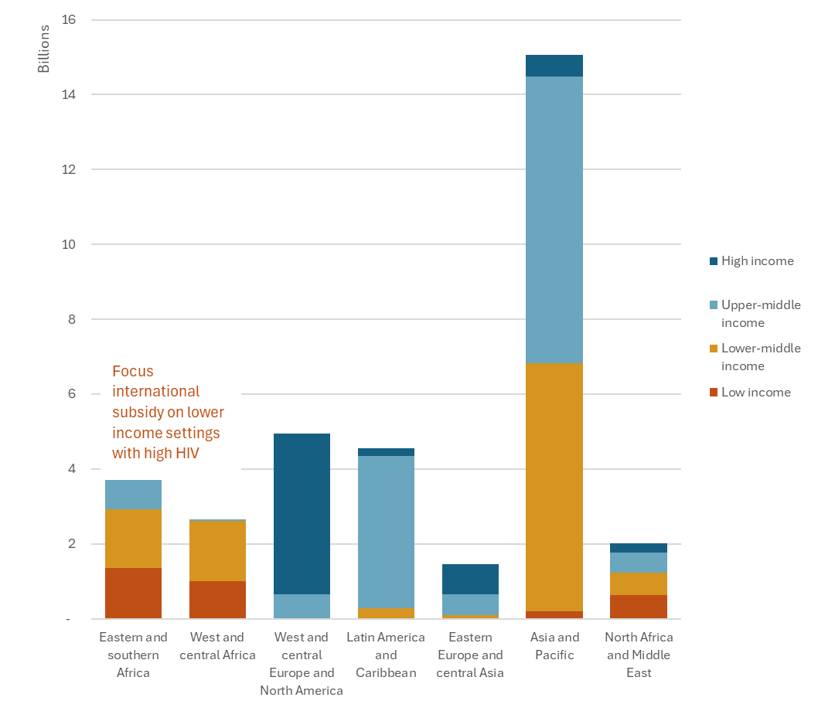

ANNEX 4. Estimated Regional Median Key Population Sizes ()

 | Proportion of the adult population (aged 15–49 years)
Region | MSM | Sex Workers | PWID | Transgender
Asia-Pacific | 0.79% | 0.30% | 0.15% | 0.09%
Caribbean | 2.49% | 1.78% | 0.17% | 0.24%
Eastern and Southern Africa | 0.68% | 0.65% | 0.12% | 0.13%
Eastern Europe and Central Asia | 1.06% | 0.42% | 1.41% | 0.07%
Latin America | 1.43% | 0.81% | 0.17% | 0.10%
Middle East and North Africa | 0.50% | 0.38% | 0.10% | 0.13%
West and Central Africa | 0.57% | 0.79% | 0.18% | 0.09%
Western and Central Europe and North America | 2.46% | 0.43% | 0.62% | 0.29%

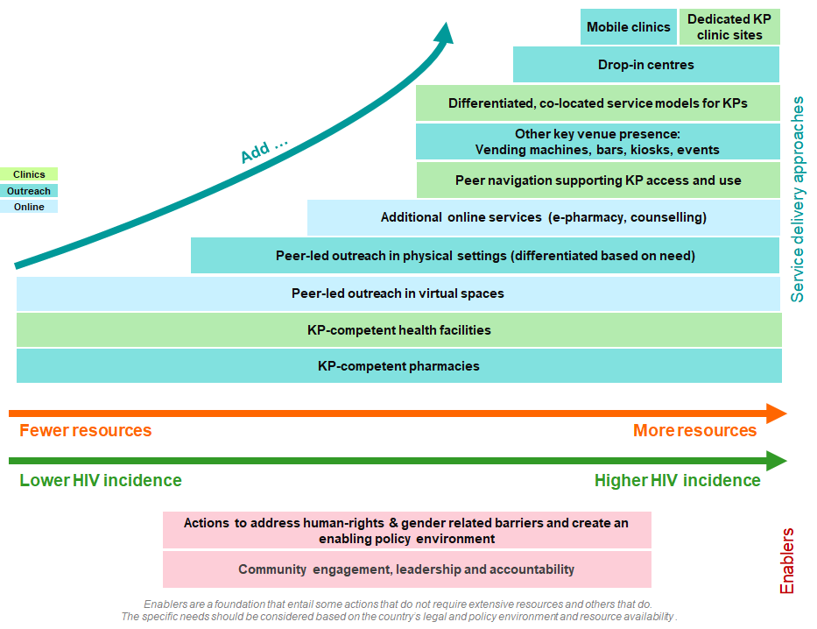
ANNEX 5. Step-wise Decision-Making Aide for Key Population Delivery Models ()

ANNEX 6. HIV Prevention Resource Needs

Note: In all charts the breakdown by method is only indicative as assumptions needed to be made to estimate cost, which differs for different products. The exact share of each method, in particular new long-acting products, cannot be precisely predicted as it will depend on user preferences, evolving prices and potentially new products on the market.

- Share of Resource Needs (in % of amounts in USD) in 2030 of HIV Prevention Commodities, by UNAIDS Region

- 2030 Resource Needs for PrEP Commodities

By year and estimated indicative breakdown by option

By and sub-population (2030, young people aged 15-24 and adults 25+, key populations)

By region and prevention option (2030)

C. Distribution of 2030 HIV Resource Need for Primary Prevention, by Region ()

D. Distribution of Resource Needs for HIV Primary Prevention by 2030, Top Countries

ANNEX 7. Proportion of HIV Resources Spent on Prevention, Select Countries

Country | Year | % of Total HIV Resources Spent on Prevention | % of Domestic HIV Resources Spent on Prevention
Afghanistan | 2024 | 49% | 0%
Angola | 2024 | 10% | 9%
Antigua and Barbuda | 2023 | 9% | 9%
Armenia | 2024 | 35% | 18%
Azerbaijan | 2024 | 29% | 28%
Bangladesh | 2023 | 39% | 21%
Belize | 2023 | 8% | 3%
Benin | 2024 | 35% | 18%
Bhutan | 2024 | 45% | 0%
Brazil | 2024 | 7% | 7%
Burkina Faso | 2024 | 4% | 6%
Central African Republic | 2024 | 3% | 0%
Chile | 2024 | 28% | 28%
Costa Rica | 2024 | 5% | 5%
Dominica | 2023 | 50% | 50%
Dominican Republic | 2024 | 20% | 23%
El Salvador | 2024 | 18% | 19%
Ethiopia | 2023 | 10% | 12%
Georgia | 2024 | 50% | 47%
Ghana | 2023 | 8% | 1%
Guatemala | 2024 | 37% | 29%
Guinea | 2024 | 4% | 0%
Honduras | 2024 | 33% | 32%
India | 2024 | 24% | 24%
Kazakhstan | 2024 | 8% | 6%
Kenya | 2024 | 8% | 5%
Kyrgyzstan | 2024 | 13% | 1%
Lao PDR | 2024 | 30% | 23%
Malawi | 2024 | 15% | 0%
Malaysia | 2024 | 14% | 10%
Mali | 2024 | 38% | 38%
Nepal | 2024 | 21% | 1%
Panama | 2024 | 19% | 23%
Papua New Guinea | 2023 | 14% | 4%
Peru | 2024 | 43% | 44%
Philippines | 2024 | 6% | 6%
Republic of Moldova | 2024 | 34% | 28%
Rwanda | 2024 | 8% | 0%
Seychelles | 2024 | 35% | 37%
Singapore | 2024 | 6% | 6%
South Africa | 2024 | 9% | 5%
Tajikistan | 2023 | 32% | 13%
Thailand | 2023 | 15% | 12%
Timor-Leste | 2024 | 49% | 57%
Togo | 2024 | 11% | 6%
Uzbekistan | 2023 | 19% | 11%
Zimbabwe | 2023 | 21% | 0%
TOTAL | 23/24 | 11% | 8%

ANNEX 8. Useful HIV Prevention Resources

PREVENTION PLANNING TOOLS
- UNAIDS HIV Estimates Training Materials (online here)
- UNAIDS Key Populations Atlas (online here)
- UNAIDS HIV Financial Dashboard (online here)
- UNAIDS Condom Needs Assessment Tool (online here)
- UNAIDS and WHO BBS-lite Implementation Tool (online here)
- Naomi HIV sub-national estimates viewer (online here)
- Sub-national HIV Estimates in Priority Populations (SHIPP) (online here)
- World Bank Optima HIV Model (online here)
- PrEP-it Implementation Planning, Monitoring and Evaluation Tool (online here)
- FHI360 Toolkit to design social media campaigns that promote condom use (online here)
- WHO implementation tool for PrEP of HIV infection (online here)
- GPC Five HIV prevention self-assessment tools (PSATs) (online here)

TECHNICAL GUIDANCE ON HIV PREVENTION
- WHO Differentiated and simplified PrEP for HIV prevention (online here)
- WHO Guidelines on lenacapavir for HIV prevention and testing strategies for long-acting injectable pre-exposure prophylaxis (online here)
- WHO Preventing HIV through safe VMMC for adolescent boys and men in generalized HIV epidemics (online here)
- WHO Consolidated guidelines on HIV, viral hepatitis and STI prevention, diagnosis, treatment and care for key populations (online here)

PREVENTION SUSTAINABILITY
- HIV Leadership Forum Implementing social contracting for HIV prevention (online here)
- GPC Social contracting: Concepts and examples (online here, or here)
- GPC Supporting Prioritization in the Context of HIV Funding Cuts (online here)
- Strengthening National Leadership for Sustainable HIV (Prevention) Programs: A Policy Brief for Government Leaders (online here)

HIV PREVENTION PROGRESS REPORTS
- GPC Key findings from the 2023 Global HIV Prevention Coalition scorecards (online here)
- UNAIDS 2025 Global AIDS Update (online here)

OTHER RESOURCES ON HIV PREVENTION
- South-to-South Learning Network on HIV Prevention (online here)
- New directions in measuring combination HIV prevention (online here)

REFERENCES

People living with HIV are also an important population to engage in prevention. Several prevention options including condoms, clean needles and syringes and OAMT have non-HIV benefits for people living with HIV and prevention benefits for their sexual partners. People living with HIV should also not be excluded from VMMC. Their lived experience with HIV can also make people living with HIV trusted sources for HIV related information, prevention messaging and peer support.
The target refers to 20 million person-years on PrEP. This is approximately double the 2025 target of 10.6 million person-years.
The target represents populations with regular and non-regular partners aged 15-49 in sub-national locations and HIV incidence rates exceeding 0.2%. Absolute numbers are not available as baselines for this and the following population-based targets, because not all countries report these numbers currently. The proportions used as baseline represent the countries that reported data for 2024.
. UNAIDS (2025). AIDS, crisis and the power to transform: UNAIDS Global AIDS Update 2025. Geneva: Joint United Nations Programme on HIV/AIDS; 2025. Licence: CC BY-NC-SA 3.0 IGO. Page 16. Online at https://www.unaids.org/en/resources/documents/2025/2025-global-aids-update
. UNAIDS (2024). HIV Prevention: From Crisis to Opportunity: Key findings from the 2023 Global HIV Prevention Coalition scorecards. Page 43. Online at https://www.unaids.org/sites/default/files/media_asset/2023-global-hiv-prevention-coalition-scorecards-key-findings_en.pdf
. UNAIDS (2025). AIDS, crisis and the power to transform: UNAIDS Global AIDS Update 2025. Geneva: Joint United Nations Programme on HIV/AIDS; 2025. Licence: CC BY-NC-SA 3.0 IGO. Page 57. Online at https://www.unaids.org/en/resources/documents/2025/2025-global-aids-update
. UNAIDS (2025). AIDS, crisis and the power to transform: UNAIDS Global AIDS Update 2025. Geneva: Joint United Nations Programme on HIV/AIDS; 2025. Licence: CC BY-NC-SA 3.0 IGO. Page 66. Online at https://www.unaids.org/en/resources/documents/2025/2025-global-aids-update
. UNAIDS (2025). AIDS, crisis and the power to transform: UNAIDS Global AIDS Update 2025. Geneva: Joint United Nations Programme on HIV/AIDS; 2025. Licence: CC BY-NC-SA 3.0 IGO. Page 62. Online at https://www.unaids.org/en/resources/documents/2025/2025-global-aids-update
. Venter, W. D. F., Gandhi, M., Sokhela, S., Sikwese, K., Bygrave, H., Da Gama, L., ... & Hill, A. (2024). The long wait for long-acting HIV prevention and treatment formulations. The Lancet HIV, 11(10), e711-e716. Online at https://pubmed.ncbi.nlm.nih.gov/39159655/
. Marcus, J. L., Sewell, W. C., Balzer, L. B., & Krakower, D. S. (2020). Artificial intelligence and machine learning for HIV prevention: emerging approaches to ending the epidemic. Current HIV/AIDS Reports, 17(3), 171-179. Online at https://link.springer.com/article/10.1007/s11904-020-00490-6
. Sandefur, J. & Kenny, C. (2025, March 26). USAID Cuts: New Estimates at the Country Level. Center For Global Development. Online at https://www.cgdev.org/blog/usaid-cuts-new-estimates-country-level
. U.S. State Department (2025). Congressional Budget Justification: Department of State, Foreign Operations, and Related Programs – Fiscal Year 2026. Online at https://www.state.gov/wp-content/uploads/2025/05/FY-2026-State-CBJ-.pdf, as cited in KFF (2025. Administration Releases Additional Details of Fiscal Year 2026 Budget Request. Online at https://www.kff.org/global-health-policy/fact-sheet/administration-releases-additional-details-of-fiscal-year-2026-budget-request/
. Global Fund (2025). Grant Adaptation Measures for Grant Cycle 7. Online at https://resources.theglobalfund.org/en/updates/2025-05-16-gc7-grant-adaptation-measures/
. Alcorn, K. (2025). US funding cuts cause immediate drops in numbers testing and on HIV treatment. Aidsmap. Online at https://www.aidsmap.com/news/jul-2025/us-funding-cuts-cause-immediate-drops-numbers-testing-and-hiv-treatment
. AVAC (2025, May 25). PrEP Delivery Imperiled. Online at https://avac.org/resource/infographic/prep-delivery-imperiled/
. UNAIDS (2025, April 28). Fact Sheet A snapshot on HIV commodity availability and management risks Status as of 28 April 2025. Page 2. Online at https://www.unaids.org/sites/default/files/2025-05/UNAIDS_focused-analysis_HIV-commodities_en.pdf
. UNAIDS (2025). AIDS, crisis and the power to transform: UNAIDS Global AIDS Update 2025. Geneva: Joint United Nations Programme on HIV/AIDS; 2025. Licence: CC BY-NC-SA 3.0 IGO. Page 57. Online at https://www.unaids.org/en/resources/documents/2025/2025-global-aids-update
. UNAIDS (2025). AIDS, crisis and the power to transform: UNAIDS Global AIDS Update 2025. Geneva: Joint United Nations Programme on HIV/AIDS; 2025. Licence: CC BY-NC-SA 3.0 IGO. Page 55. Online at https://www.unaids.org/en/resources/documents/2025/2025-global-aids-update
. UNAIDS (2025). AIDS, crisis and the power to transform: UNAIDS Global AIDS Update 2025. Geneva: Joint United Nations Programme on HIV/AIDS; 2025. Licence: CC BY-NC-SA 3.0 IGO. Page 57. Online at https://www.unaids.org/en/resources/documents/2025/2025-global-aids-update
. Stover, J., Sonneveldt, E., Tam, Y., Horton, K. C., Phillips, A. N., Smith, J., Martin-Hughes, R., Ten Brink, D., Citron, D. T., Kim, H.-Y., Akullian, A., Mudimu, E., Pickles, M., Bershteyn, A., Williamson, J., Meyer-Rath, G., Jamieson, L., Sully, E. A., White, J. N., Heaton, A., Clark, R. A., Tong, H., Richards, A. S., McQuaid, C. F., Houben, R. M. G. J., White, R. G., Dimitrov, D., & Kaftan, D. (2025). Effects of reductions in US foreign assistance on HIV, tuberculosis, family planning, and maternal and child health: A modelling study. The Lancet Global Health, 13(10), e1669-e1680. https://doi.org/10.1016/S2214-109X(25)00281-5
. https://aidsinfo.unaids.org/
. The effectiveness of behavioural interventions to prevention HIV. A compendium of evidence. Geneva: Global HIV Prevention Coalition; 2017, updated 2019. The-effectiveness-of-behavioural-interventions-to-prevent-HIV.-A-compendium-of-evidence_final.pdf
. WHO (2022). Consolidated guidelines on HIV, viral hepatitis and STI prevention, diagnosis, treatment and care for key populations. Page 44. Online at https://www.who.int/publications/i/item/9789240052390
. WHO (2022). Consolidated guidelines on person-centred HIV strategic information: strengthening routine data for impact. Online at https://www.who.int/publications/i/item/9789240055315
. Global Fund (2025). GC7 Programmatic Reprioritization Approach "Protecting and enabling access to lifesaving services". Page 20. Online at https://resources.theglobalfund.org/en/updates/2025-06-06-gc7-grant-reprioritization/
. Zimbabwe Ministry of Health and Childcare (2019). Comprehensive National HIV Communications Strategy for Zimbabwe: 2019-2025. Online at https://www.prepwatch.org/wp-content/uploads/2022/07/Zimbabwe-National-HIV-Communications-Strategy-2019-2025.pdf
. Kamitani, E., Mizuno, Y., Khalil, G. M., Viguerie, A., DeLuca, J. B., & Mishra, N. (2024). Improving HIV preexposure prophylaxis uptake with artificial intelligence and automation: a systematic review. AIDS, 38(10), 1560-1569. Online at https://journals.lww.com/aidsonline/abstract/2024/08010/improving_hiv_preexposure_prophylaxis_uptake_with.14.aspx
. Rice, E., Yoshioka-Maxwell, A., Petering, R., Onasch-Vera, L., Craddock, J., Tambe, M., ... & Wilson, N. (2018). Piloting the use of artificial intelligence to enhance HIV prevention interventions for youth experiencing homelessness. Journal of the Society for Social Work and Research, 9(4), 551-573. Online at https://www.journals.uchicago.edu/doi/full/10.1086/701439
. Wilder, B., Onasch-Vera, L., Diguiseppi, G., Petering, R., Hill, C., Yadav, A., ... & Tambe, M. (2021, May). Clinical trial of an AI-augmented intervention for HIV prevention in youth experiencing homelessness. In Proceedings of the AAAI Conference on Artificial Intelligence (Vol. 35, No. 17, pp. 14948-14956). Online at https://www.journals.uchicago.edu/doi/pdf/10.1086/701439
Global HIV prevention is not on track: how a health systems approach can promote sustainable progress in African countries. Matanje, Beatrice et al. The Lancet HIV, Volume 13, Issue 1, e40 - e49. Online at https://www.thelancet.com/journals/lanhiv/article/PIIS2352-3018(25)00270-X/fulltext
Global HIV Prevention Coalition. Scalable and sustainable primary HIV prevention models for people from key populations. Geneva: Joint United Nations Programme on HIV/AIDS (UNAIDS), World Health Organization (WHO); 2026.
Global HIV Prevention Coalition (2025). Planning and managing HIV Programmes with Key Populations. Geneva, 2025. https://hivpreventioncoalition.unaids.org/en/resources/planning-and-managing-hiv-programmes-key-populations
Global HIV Prevention Coalition. Decision-making Aide for Investments into HIV Prevention Programmes among Adolescent Girls and Young Women. https://files-hivpreventioncoalition.unaids.org/gpc/attachments/AGYW-DMA-2023.pdf
. Goldstein, D., Salvatore, M., Ferris, R., Phelps, B. R., & Minior, T. (2023). Integrating global HIV services with primary health care: a key step in sustainable HIV epidemic control. The Lancet Global Health, 11(7), e1120-e1124. Online at https://www.thelancet.com/journals/langlo/article/PIIS2214-109X(23)00156-0/fulltext
Actions for improved clinical and prevention services and choices: preventing HIV and other sexually transmitted infections among women and girls using contraceptive services in contexts with high HIV incidence. Geneva: World Health Organization; https://www.unaids.org/sites/default/files/media_asset/preventing-hiv-sti-among-women-girls-using-contraceptive-services_en.pdf
. Coleman, M., Akolo, C., Mbanusi, A., Sithole, B., Siberry, G. K., Schowen, R., & Goldstein, D. (2025). Integrating HIV and primary healthcare for key populations: community‐led models from Vietnam, Nigeria and Eswatini. Journal of the International AIDS Society, 28(9), e70027. Online at https://onlinelibrary.wiley.com/doi/full/10.1002/jia2.70027
. See Malaysia AIDS Foundation (2022). Malaysian AIDS Foundation Annual Report 2021. Online at https://mac.org.my/v4/wp-content/uploads/2023/05/Annual-Report-2021_MAC_A4_.pdf as well as Suleiman, A. (2024). Seamless Care: Integrating HIV Services into Primary Health Care Model. Online at https://www.iasociety.org/sites/default/files/EduFund/meeting-material/pakistan/SeamlessCare-IntegrationOfHIVServicesIntoPHC-MalaysiaModel_AnitaSuleiman.pdf
. INHSU (2021). 6 Key Takeaways – Universal Health Coverage for People Who Use Drugs. Online at https://inhsu.org/features/6-key-takeaways-universal-health-coverage-for-people-who-use-drugs/
. Coleman, M., Akolo, C., Mbanusi, A., Sithole, B., Siberry, G. K., Schowen, R., & Goldstein, D. (2025). Integrating HIV and primary healthcare for key populations: community‐led models from Vietnam, Nigeria and Eswatini. Journal of the International AIDS Society, 28(9), e70027. Online at https://onlinelibrary.wiley.com/doi/full/10.1002/jia2.70027
Rousseau, E., Julies, R. F., Madubela, N., & Kassim, S. (2021). Novel platforms for biomedical HIV prevention delivery to key populations—community mobile clinics, peer-supported, pharmacy-led PrEP delivery, and the use of telemedicine. Current HIV/AIDS Reports, 1-8. Online at https://link.springer.com/article/10.1007/s11904-021-00578-7
. Global Prevention Coalition (2025). Planning and Managing HIV Programmes with Key Populations: Considerations for delivering and sustaining HIV services through trusted access platforms for sex workers, people who use drugs, men who have sex with men and trans and gender diverse people. Forthcoming.
. UNAIDS (2025). AIDS, crisis and the power to transform: UNAIDS Global AIDS Update 2025. Geneva: Joint United Nations Programme on HIV/AIDS; 2025. Licence: CC BY-NC-SA 3.0 IGO. Page 88. Online at https://www.unaids.org/en/resources/documents/2025/2025-global-aids-update
. UNAIDS & WHO (2022). Policy Brief: Virtual interventions in response to HIV, sexually transmitted infections and viral hepatitis Innovate—Implement—Integrate. Online at https://www.unaids.org/sites/default/files/media_asset/policy-brief_virtual-interventions_en.pdf
. Patel, P., Kerzner, M., Reed, J. B., Sullivan, P. S., & El-Sadr, W. M. (2022). Public health implications of adapting HIV pre-exposure prophylaxis programs for virtual service delivery in the context of the COVID-19 pandemic: systematic review. JMIR Public Health and Surveillance, 8(6), e37479. Online at https://publichealth.jmir.org/2022/6/e37479/
. Audere &Desmond Tutu Health Foundation (2025). Artificial intelligence to enhance HIV prevention in age of disruptions: Recommendations from the Audere and Desmond Tutu Health Foundation Expert Consultation. Page 5. Online at https://static1.squarespace.com/static/64ff6a6dd00b77132a60f99b/t/687023a99f37d903417775b8/1752179626426/Leveraging+AI+to+enhance+HIV+prevention+v3.pdf
. Dalal, S., Mathers, B., Stelzle, D., Nyagah, L. M., Agbo, F., Annang, D., Bhavsar, S. P., Mbiriyawanda, S., Mhlanga, B., Molapo, T., Moro, L., Mudiope, P., Ngwali, L., Nyirenda, M. S., Sathane, I., Adhikary, R., Alonso Gonzalez, M., Chan, P., Gerritsen, A., Izumi, K., Jati, I. R. A. P., Jinga, N., Jung, K., Kalibala, S., Kato, M., Kayibanda, J. F., Kouassi, D., Kumar, S., Kusi, B., Maiga, A., Maqungo, L., Maulana, S., McClure, C., Mejía, A. A., Molapo, S., Mphahlele, K., Mukiza, N., Munzara, W., Mutseyekwa, T., Ngowi, K. M., Nkhata, M. J., Nkhoma, J., Odhiambo, J., Osei, I., Pinyol-Jiménez, G., Price, J., Rabajoli, A., Rani, R., Rewari, B. B., Ryan, C., Shao, A., Sheriff, I., Skarbinski, J., Stover, J., Takaku, Y., Talib, M. I., Tura, A. K., Ujeneza, E., Varma, J. K., Verster, A., Wapling, J., Whalen, C. C., Wilkinson, L., Wit, F. W., Zucman, D., & Low-Beer, D. (2025). Harnessing digital health data for person-centred HIV prevention monitoring: A survey of national health information systems. Journal of the International AIDS Society, 28(Suppl 5), e70039. https://doi.org/10.1002/jia2.70039
. Global HIV Prevention Coalition (2025). Prioritized, efficient, effective and sustainable prevention at a time of uncertain financing: Considerations for countries to make in 2025 with a 2030 horizon. Slide 26. Online at https://hivpreventioncoalition.unaids.org/en/resources/supporting-prioritization-context-hiv-funding-cuts
. Naidoo, N. P., Ayieko, J., & Fonner, V. A. (2025). Expanding access to a choice‐based multi‐method PrEP market for HIV prevention. Journal of the International AIDS Society, 28(Suppl 2), e26512. Online at https://onlinelibrary.wiley.com/doi/10.1002/jia2.26512
. Phillips, A. N., Hickey, M. D., Shade, S. B., Kabami, J., Ayieko, J., Revill, P., Kakande, E., Balzer, L. B., Sutter, N., Bansi-Matharu, L., Smith, J., Chamie, G., Havlir, D. V., Kamya, M. R., Petersen, M. (2025). Dynamic choice HIV prevention with long-acting injectable cabotegravir pre-exposure prophylaxis in east, central, southern, and west Africa: A cost-effectiveness modelling analysis. The Lancet HIV, 12(10), e701-e711. https://doi.org/10.1016/S2352-3018(25)00169-9
. UNAIDS (2022). New Directions in Measuring Combination HIV Prevention: A think tank series to align measurement of HIV prevention to the Global AIDS Strategy 2021 – 2026. Page 13. Online at https://hivpreventioncoalition.unaids.org/sites/default/files/attachments/New-Directions-in-HIV-Prevention-Measurement-Series-Report-Final.pdf
. Harm Reduction International (2023). Low Dead Space Syringes Analysis And Benefits For People Who Inject Drugs. Page 21. Online at https://hri.global/wp-content/uploads/2023/11/LDSS-report_Final.pdf
McKinnon, B., & Vandermorris, A. (2018). National age-of-consent laws and adolescent HIV testing in sub-Saharan Africa: a propensity-score matched study. Bulletin of the World Health Organization, 97(1), 42. Online at https://pmc.ncbi.nlm.nih.gov/articles/PMC6307515/pdf/BLT.18.212993.pdf
. Kavanagh, M. M., Agbla, S. C., Joy, M., Aneja, K., Pillinger, M., Case, A., ... & Graeden, E. (2021). Law, criminalisation and HIV in the world: have countries that criminalise achieved more or less successful pandemic response?. BMJ Global Health, 6(8), e006315. Online at https://gh.bmj.com/content/6/8/e006315
. Sia, D., Tchouaket, É. N., Hajizadeh, M., Karemere, H., Onadja, Y., & Nandi, A. (2020). The effect of gender inequality on HIV incidence in Sub-Saharan Africa. Public health, 182, 56-63. Online at https://www.sciencedirect.com/science/article/abs/pii/S003335062030024X
. Li, Y., Marshall, C. M., Rees, H. C., Nunez, A., Ezeanolue, E. E., & Ehiri, J. E. (2014). Intimate partner violence and HIV infection among women: a systematic review and meta‐analysis. African Journal of Reproduction and Gynaecological Endoscopy, 17(1). Online at https://onlinelibrary.wiley.com/doi/pdfdirect/10.7448/IAS.17.1.18845
. Lyons, C. E., Rwema, J. O. T., Makofane, K., Diouf, D., Njindam, I. M., Ba, I., ... & Baral, S. (2023). Associations between punitive policies and legal barriers to consensual same-sex sexual acts and HIV among gay men and other men who have sex with men in sub-Saharan Africa: a multicountry, respondent-driven sampling survey. The Lancet HIV, 10(3), e186-e194. Online at https://www.sciencedirect.com/science/article/am/pii/S2352301822003368
. Sustainable HIV Prevention Initiative (2025). Strengthening National Leadership for Sustainable HIV Programs: A Policy Brief for Government Leaders. Page 6. Online at https://www.blantyrepreventionstrategy.com/national-leadership-for-sustainable-hiv-programs/a-policy-brief
. Sustainable HIV Prevention Initiative (2025). Strengthening National Leadership for Sustainable HIV Programs: A Policy Brief for Government Leaders. Page 6. Online at https://www.blantyrepreventionstrategy.com/national-leadership-for-sustainable-hiv-programs/a-policy-brief
. Pharos Global Health Advisors for the Botswana National AIDS and Health Promotion Council (2024). Botswana: Sustainability and Transition Readiness Assessment and Roadmap for HIV and TB. Online at https://pharosglobalhealth.com/projects/botswana-hiv-sustainability-and-transition-roadmap/
. HIV Leadership Forum (2023). Sustaining Effective Leadership to Secure Gains, Bridge Disparities and Expedite Progress A position paper on the leadership role of national AIDS coordinating authorities in the future of HIV prevention, sustainable health and preventing future pandemics. Online at https://cdn.prod.website-files.com/63ff2c1bed17e622bce9c2ea/65672199206bd9877c96d9c9_PP_HIV_en_dig.pdf
. Kelly, S. L., Martin-Hughes, R., Stuart, R. M., Yap, X. F., Kedziora, D. J., Grantham, K. L., ... & Wilson, D. P. (2018). The global Optima HIV allocative efficiency model: targeting resources in efforts to end AIDS. The lancet HIV, 5(4), e190-e198.
. Global HIV Prevention Coalition (2025). Prioritized, efficient, effective and sustainable prevention at a time of uncertain financing: Considerations for countries to make in 2025 with a 2030 horizon. Online at https://hivpreventioncoalition.unaids.org/en/resources/supporting-prioritization-context-hiv-funding-cuts
. Global Fund (2025) GC7 Programmatic Reprioritization Approach Protecting and enabling access to lifesaving services. Online at https://resources.theglobalfund.org/media/sveowiic/cr_gc7-programmatic-reprioritization-approach_summary_en.pdf
. World Health Organization (2025) Sustaining priority HIV, viral hepatitis and STI services in a changing funding landscape: operational guidance. Online at https://www.who.int/publications/m/item/HQ-2025-00573
. Silhol, R., Booton, R. D., Mitchell, K. M., Stannah, J., Stevens, O., Dimitrov, D., ... & Boily, M. C. (2025). Identifying priority populations for HIV interventions using acquisition and transmission indicators: a combined analysis of 15 mathematical models from 10 African countries. medRxiv, 2025-03. Online at https://www.medrxiv.org/content/10.1101/2025.03.17.25324139v1.full
Silhol, R., Anderson, R. L., Stevens, O., Stannah, J., Booton, R. D., Baral, S., ... & Boily, M. C. (2024). Measuring HIV acquisitions among partners of Key populations: estimates from HIV Transmission Dynamic models. JAIDS Journal of Acquired Immune Deficiency Syndromes, 95(1S), e59-e69. Online at https://journals.lww.com/jaids/fulltext/2024/01011/measuring_hiv_acquisitions_among_partners_of_key.7.aspx?context=latestarticles
. UNAIDS (2022). New Directions in Measuring Combination HIV Prevention: A think tank series to align measurement of HIV prevention to the Global AIDS Strategy 2021 – 2026. Page 8. Online at https://hivpreventioncoalition.unaids.org/sites/default/files/attachments/New-Directions-in-HIV-Prevention-Measurement-Series-Report-Final.pdf
. Korenromp, E. L., Sabin, K., Stover, J., Brown, T., Johnson, L. F., Martin-Hughes, R., ... & Mahy, M. (2024). New HIV infections among key populations and their partners in 2010 and 2022, by world region: a multisources estimation. JAIDS Journal of Acquired Immune Deficiency Syndromes, 95(1S), e34-e45.
17. UNAIDS (2025). AIDS, crisis and the power to transform: UNAIDS Global AIDS Update 2025. Geneva: Joint United Nations Programme on HIV/AIDS; 2025. Licence: CC BY-NC-SA 3.0 IGO. Page 19. Online at https://www.unaids.org/en/resources/documents/2025/2025-global-aids-update
. Neal, J. J., Prybylski, D., Sanchez, T., & Hladik, W. (2020). Population size estimation methods: searching for the holy grail. JMIR Public Health and Surveillance, 6(4), e25076. Online at https://publichealth.jmir.org/2020/4/e25076
. Malburg, C. M., Gutreuter, S., Ruiseñor-Escudero, H., Abdul-Quader, A., & Hladik, W. (2025). Population Size Estimation of Men Who Have Sex With Men in Low-and Middle-Income Countries: Google Trends Analysis. JMIR Public Health and Surveillance, 11, e58630.
. Banadakoppa Manjappa, R., Bhattacharjee, P., Shaw, S. Y. N., Gitonga, J., Kioko, J., Songok, F., ... & Blanchard, J. (2024). A sub‐national HIV epidemic appraisal in Kenya: a new approach for identifying priority geographies, populations and programmes for optimizing coverage for HIV prevention. Journal of the International AIDS Society, 27, e26245. Online at https://onlinelibrary.wiley.com/doi/pdf/10.1002/jia2.26245
. Platt, L., Wut Yee Kyaw, K., Rathod, S. D., Yu Naing, A., Garkov, S., Bijl, M., & Roberts, B. (2025). The effect of location in mining or borderland areas on HIV incidence among people who use drugs attending a harm reduction programme in Myanmar, 2014–2021: A retrospective cohort study. PloS one, 20(5), e0295727. Online at https://journals.plos.org/plosone/article?id=10.1371/journal.pone.0295727
. Dietler, D., Farnham, A., Lyatuu, I., Fink, G., & Winkler, M. S. (2022). Industrial mining and HIV risk: evidence from 39 mine openings across 16 countries in sub-Saharan Africa. Aids, 36(11), 1573-1581.
. CNCS (2022). Mozambique National HIV Prevention Road Map 2022–2025. Page 49. Online at https://hivpreventioncoalition.unaids.org/en/resources/national-hiv-prevention-road-map-2022-2025-mocambique
. Versteegh, L., Amatavete, S., Chinbunchorn, T., Thammasiha, N., Mukherjee, S., Popping, S., ... & van de Vijver, D. (2022). The epidemiological impact and cost-effectiveness of key population-led PrEP delivery to prevent HIV among men who have sex with men in Thailand: A modelling study. The Lancet Regional Health-Southeast Asia, 7. Online at https://www.thelancet.com/journals/lansea/article/PIIS2772-3682(22)00113-5/fulltext
. Versteegh, L., Amatavete, S., Chinbunchorn, T., Thammasiha, N., Mukherjee, S., Popping, S., ... & van de Vijver, D. (2022). The epidemiological impact and cost-effectiveness of key population-led PrEP delivery to prevent HIV among men who have sex with men in Thailand: A modelling study. The Lancet Regional Health-Southeast Asia, 7. Online at https://www.thelancet.com/journals/lansea/article/PIIS2772-3682(22)00113-5/fulltext
Noriega Minichiello, S., Costenbader, B., Homan, R., Shrestha, B., Saidou Tall, M. M., & Eveslage, B. (2024, July 22-26). Cost and service utilization of online and in-person HIV services in Mali and Nepal [Conference presentation]. AIDS 2024, Munich, Germany and virtual. Online at https://plus.iasociety.org/sites/default/files/2024-09/e-poster_996.pdf
. Thuo, N., Bardon, A. R., Mogere, P., Kiptinness, C., Casmir, E., Wairimu, N., ... & Ortblad, K. F. (2024). Acceptability of six-monthly PrEP dispensing supported with interim HIV self-testing to simplify PrEP delivery in Kenya: findings from qualitative research. BMC Health Services Research, 24(1), 1281. Online at https://linkinghub.elsevier.com/retrieve/pii/S2352301822001266
. Kelly, S. L., Martin-Hughes, R., Stuart, R. M., Yap, X. F., Kedziora, D. J., Grantham, K. L., ... & Wilson, D. P. (2018). The global Optima HIV allocative efficiency model: targeting resources in efforts to end AIDS. The lancet HIV, 5(4), e190-e198.
. Chevalier, J. M., Hansen, M. A., Coskun, E., Sy, K. T. L., Drakes, J., Dowling, S., ... & Nichols, B. E. (2024). Cost-effectiveness of intervention combinations towards the elimination of vertical transmission of HIV in limited-resource settings: a mathematical modelling study. The Lancet Global Health, 12(3), e457-e466. Online at https://www.sciencedirect.com/science/article/pii/S2214109X23005880
. UNAIDS (2025). AIDS, crisis and the power to transform: UNAIDS Global AIDS Update 2025. Geneva: Joint United Nations Programme on HIV/AIDS; 2025. Licence: CC BY-NC-SA 3.0 IGO. Page 112. Online at https://www.unaids.org/en/resources/documents/2025/2025-global-aids-update
. Stone, J., Bothma, R., Gómez, G. B., Eakle, R., Mukandavire, C., Subedar, H., Fraser, H., Boily, M.-C., Schwartz, S., Coetzee, J., Otwombe, K., Milovanovic, M., Baral, S., Johnson, L. F., Venter, W. D. F., Rees, H., & Vickerman, P. (2023). Impact and cost-effectiveness of the national scale-up of HIV pre-exposure prophylaxis among female sex workers in South Africa: A modelling analysis. Journal of the International AIDS Society, 26(2), e26063. Online a https://doi.org/10.1002/jia2.26063
. Pebody, R. (2025, July 23). Does six-monthly PrEP have a future following the collapse of global HIV funding? aidsmap. Retrieved from https://www.aidsmap.com/news/jul-2025/does-six-monthly-prep-have-future-following-collapse-global-hiv-funding
. UNAIDS (2021). Global AIDS Strategy 2021-2026 — End Inequalities. End AIDS. Page 103. Online at https://www.unaids.org/sites/default/files/media_asset/global-AIDS-strategy-2021-2026_en.pdf & UNAIDS (2025). AIDS, crisis and the power to transform: UNAIDS Global AIDS Update 2025. Geneva: Joint United Nations Programme on HIV/AIDS; 2025. Licence: CC BY-NC-SA 3.0 IGO. Page 112-113. Online at https://www.unaids.org/en/resources/documents/2025/2025-global-aids-update
. CIGH (2025). Strengthening National Leadership for Sustainable HIV Programs: A Policy Brief for Government Leaders. Georgetown University, Center for Innovation in Global Health (CIGH). Online at https://www.blantyrepreventionstrategy.com/national-leadership-for-sustainable-hiv-programs/a-policy-brief
. UNAIDS (2025). AIDS, crisis and the power to transform: UNAIDS Global AIDS Update 2025. Geneva: Joint United Nations Programme on HIV/AIDS; 2025. Licence: CC BY-NC-SA 3.0 IGO. Page 103. Online at https://www.unaids.org/en/resources/documents/2025/2025-global-aids-update
. Stone J, et al (2025). Modelling the impact of cuts in PEPFAR funding for HIV pre-exposure prophylaxis among key populations in sub-Saharan Africa. 13th International AIDS Society Conference on HIV Science, Kigali, abstract no OAS0103LB, 2025. As cited in Cairs, G. (2025, July 17). Scaling back PEPFAR will leave 700,000 without PrEP and cause 6700 new HIV infections within a year. Online at https://www.aidsmap.com/news/jul-2025/scaling-back-pepfar-will-leave-700000-without-prep-and-cause-6700-new-hiv-infections
. 2025 Global AIDS Monitoring Dataset. Online at https://hivfinancial.unaids.org/hivfinancialdashboards.html
. UNAIDS (2024, December 19). HIV financial data: A transformative power to ensure sustainability of the AIDS response. UNAIDS Feature Story. Online at https://www.unaids.org/en/resources/presscentre/featurestories/2024/december/20241219_hiv-financial-data
. Malaysia AIDS Foundation (2024). Malaysian AIDS Foundation Annual Report 2023. Page 43 and 74. Online at https://maf.org.my/V2/wp-content/uploads/2024/08/Annual-Report-2023_MAF_A4_A_07082024-s.pdf
. Malawi’s HIV funding landscape given the US funding cuts using the UNAIDS RAFT (Rapid Assessment Financing Tool). Malawi Cabinet Paper on HIV Commodity Security. 9 April 2025.
. UNAIDS (2019). HIV And Universal Health Coverage A Guide For Civil Society – UNAIDS Explainer. Online at https://www.unaids.org/en/resources/documents/2019/hiv-uhc-guide-civil-society
. Viriyathorn, S., Sachdev, S., Suwanwela, W., Wangbanjongkun, W., Patcharanarumol, W., & Tangcharoensathien, V. (2023). Procedural fairness in benefit package design: inclusion of pre-exposure prophylaxis of HIV in Universal Coverage Scheme in Thailand. Health Policy and Planning, 38(Suppl 1), i36. Online at https://pubmed.ncbi.nlm.nih.gov/37963082/
. Mendonça Gil, P. K., Conrado, D. D. S., Nascimento, A. I. D., Azevedo, M. V. D., Cunha, J. C. P. D., Koch, G. S. R., ... & Falcão de Oliveira, E. (2023). HIV pre-exposure prophylaxis and incidence of sexually transmitted infections in Brazil, 2018 to 2022: an ecological study of PrEP administration, syphilis, and socioeconomic indicators. PLOS Neglected Tropical Diseases, 17(8), e0011548. Online at https://pmc.ncbi.nlm.nih.gov/articles/PMC10446216/
. Samoun, N. (2023, July 12). Informal Economy’s Entertainment Workers Entitled to Receive Equity Card. Online at https://cambodianess.com/article/informal-economys-entertainment-workers-entitled-to-receive-equity-card
. HIV Leadership Forum (2024). Implementing social contracting for HIV prevention Policy Brief. Online https://hivpreventioncoalition.unaids.org/sites/default/files/attachments/implementing_social_contracting_for_hiv_prevention_policy_brief.pdf
. Jamaica Ministry of Health and Wellness (2021). Terms of Reference for the Implementation of Social Contracting of HIV Prevention Package of Services in Support of the National HIV Response. Online at https://www.moh.gov.jm/tenders/terms-of-reference-for-the-implementation-of-social-contracting-of-hiv-prevention-package-of-services-in-support-of-the-national-hiv-response/
. EpiC & VAAC (2024). Social Contracting Monitoring And Evaluation Framework: A Tool For Tracking Progress. Page 5. Online at https://www.fhi360.org/wp-content/uploads/2024/02/resource-epic-vietnam-social-contracting-monitoring-evaluation-framework.pdf
. Harm Reduction International (2023). Towards Domestic Public Financing And Social Contracting For Harm Reduction. Page 4. Online at https://hri.global/wp-content/uploads/2023/04/SOCIAL-CONTRACTING_FINAL.pdf
UNDP. Overcoming disruption: Communities on the frontline. New York, 2025. https://www.undp.org/stories/overcoming-disruption-communities-frontline
. Ahaibwe, G., Abdool Karim, S., Thow, A. M., Erzse, A., & Hofman, K. (2021). Barriers to, and facilitators of, the adoption of a sugar sweetened beverage tax to prevent non-communicable diseases in Uganda: a policy landscape analysis. Global Health Action, 14(1), 1892307. Online at https://www.tandfonline.com/doi/full/10.1080/16549716.2021.1892307#abstract
. Philippines Department of Health (2016). Sin Tax Law Incremental Revenue for Health Annual Report CY 2016. Page 8. Online at https://extranet.who.int/fctcapps/sites/default/files/2023-04/philippines_2018_annex-4_Sin_tax_report_2016.pdf
. Shroff, Z. C., Sparkes, S. P., Paina, L., Skarphedinsdottir, M., Gotsadze, G., Zakumumpa, H., ... & Hanson, K. (2024). Managing transitions from external assistance: cross-national learning about sustaining effective coverage. Health policy and planning, 39(Supplement_1), i50-i64. Online at https://academic.oup.com/heapol/article/39/Supplement_1/i50/7578711
. UNAIDS (2025). AIDS, crisis and the power to transform: UNAIDS Global AIDS Update 2025. Geneva: Joint United Nations Programme on HIV/AIDS; 2025. Licence: CC BY-NC-SA 3.0 IGO. Page 8 & 55. Online at https://www.unaids.org/en/resources/documents/2025/2025-global-aids-update
. Stover, J. G., Mattur, D., Siapka, M., Pliakas, T., & Valladares-Cardona, R. (2025). The impact and cost of reaching the UNAIDS global HIV targets. medRxiv, 2025-07. Page 13. Online at https://www.medrxiv.org/content/10.1101/2025.07.01.25330647v1.full.pdf
. Fortunak, J. M., Layne, J., Johnson, M., Smalley, S., Lutterodt, A., Roberts, D., Tadesse, E., Lu, J., Pinheiro, E., Wolde-Mariam, M., Hill, A., Fairhead, C. & Pepperrel, T. (2025). Lenacapavir to prevent HIV infection: updated estimated costs of production for generic treatments. Available at SSRN 5293409. Online at
. Wu, L., Kaftan, D., Wittenauer, R., Arrouzet, C., Patel, N., Saravis, A. L., ... & Sharma, M. (2024). Health and budget impact, and price threshold for cost-effectiveness of lenacapavir for PrEP in Eastern and Southern Africa: a modeling analysis. medRxiv, 2024-08. Online at https://pubmed.ncbi.nlm.nih.gov/39312933/
. Meyer-Rath, G., Jamieson, L., Johnson, L., Bekker, L. G., & Subedar, H. (2025). The cost-effectiveness and optimal price level of injectable PrEP with lenacapavir in South Africa. General Abstract Submission. Online at https://www.heroza.org/publications/the-cost-effectiveness-and-optimal-price-level-of-injectable-prep-with-lenacapavir-in-south-africa/
https://unitaid.org/news-blog/lenacapavir-for-hiv-prevention/ .
. UNAIDS (2024, December 19). HIV financial data: A transformative power to ensure sustainability of the AIDS response. UNAIDS Feature Story. Online at https://www.unaids.org/en/resources/presscentre/featurestories/2024/december/20241219_hiv-financial-data
. UNAIDS (2024) 2024 global AIDS report — The Urgency of Now: AIDS at a Crossroads. Regional Profiles. Online at https://www.unaids.org/en/resources/documents/2024/global-aids-update-2024
. Global HIV Prevention Coalition (2025). Planning and managing HIV Programmes with Key Populations. Geneva, 2025. https://hivpreventioncoalition.unaids.org/en/resources/planning-and-managing-hiv-programmes-key-populations
. UNAIDS (2025). AIDS, crisis and the power to transform: UNAIDS Global AIDS Update 2025. Geneva: Joint United Nations Programme on HIV/AIDS; 2025. Licence: CC BY-NC-SA 3.0 IGO. Page 114. Online at https://www.unaids.org/en/resources/documents/2025/2025-global-aids-update

